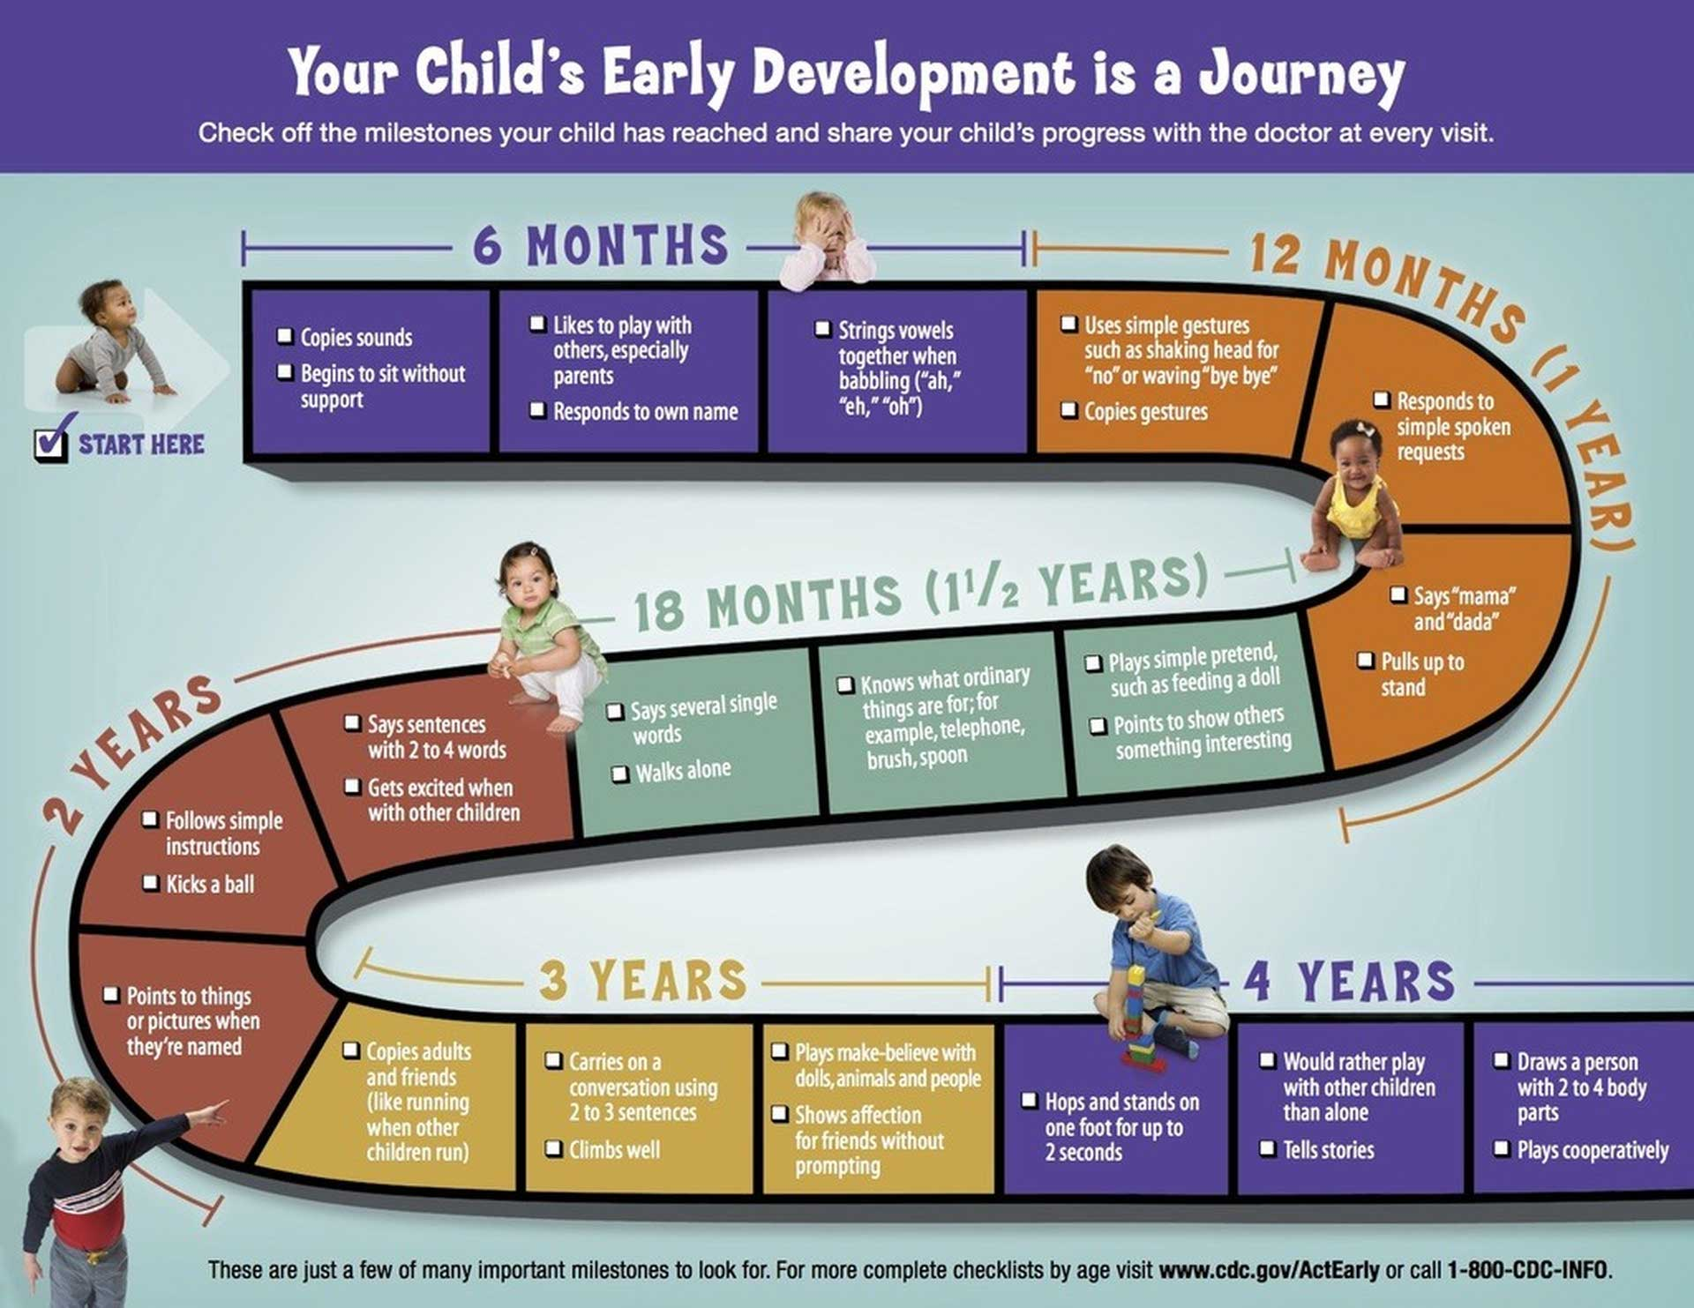

Child Development

|  |
| --- |
| Child Development |
| Child development is a fascinating process that involves changes in a child's body, mind, and emotions from birth to the end of their teenage years . It's a crucial time for a child's growth and development, and it lays the foundation for their future .  There are three main stages of childhood: early childhood, middle childhood, and late childhood (preadolescence) . Early childhood, from infancy to age six, is a time of rapid development, with milestones like learning to crawl, walk, and speak . Middle childhood, from ages six to twelve, is a period of transition between major developmental changes . Adolescence, which typically starts around puberty, is the final stage of childhood and lasts until around age 24 .  During development, children progress from being dependent on others to becoming more independent . While there's a predictable sequence to development, every child's journey is unique . This means that children may develop at different rates, and their experiences in earlier stages can influence their development in later stages .  Understanding child development is important for parents, teachers, and anyone who works with children . It helps us recognize when a child needs extra help and allows us to create environments that support their growth . For example, knowing that infants cry for long periods is normal helps us understand their needs and respond appropriately .  By understanding child development, we can better support children as they grow and learn . |

|  |
| --- |
| Reading Summary |
| * Child development is a continuous process from birth to the end of teenage years, involving changes in the body, mind, and emotions. * There are three main stages of childhood: early childhood, middle childhood, and late childhood (preadolescence), each with its own set of developmental milestones. * Understanding child development is crucial for parents, teachers, and anyone who works with children, as it helps us recognize when a child needs extra help and create supportive environments for their growth. |

Vocabulary

|  |  |  |
| --- | --- | --- |
| Term | Definition | Example Sentence |
| crucial (adjective) | extremely important or necessary | It is crucial to wear a helmet when riding a bike. |
| transition (noun) | a change from one state or condition to another | The caterpillar undergoes a transition into a butterfly. |
| adolescence (noun) | the period of time between childhood and adulthood | During adolescence, teenagers experience many physical and emotional changes. |
| dependent (adjective) | relying on someone or something else for support | A baby is dependent on its parents for food and care. |
| predictable (adjective) | able to be known or expected beforehand | The weather forecast is predictable, so we can plan our activities accordingly. |
| infancy (noun) | The stage of life from birth to about two years old, when a baby is completely dependent on others for care. | During infancy, babies learn to crawl, walk, and talk. |
| puberty (noun) | The period of time when a person's body changes and develops into an adult, usually between the ages of 8 and 14 for girls and 9 and 15 for boys. | During puberty, teenagers experience physical changes like growth spurts, the development of breasts in girls and facial hair in boys, and the start of menstruation in girls. |
| growth (noun) | The process of increasing in size or developing over time. | The plant's growth was impressive, reaching over six feet tall in just a few months. |

Multiple Choice Questions

|  |  |  |
| --- | --- | --- |
| Question #1 | Question #2 | Question #3 |
| According to the text, what is the final stage of childhood? | What is one way understanding child development can help parents and teachers? | What is a key characteristic of middle childhood, as described in the text? |
| A. Early childhood  B. Middle childhood  C. Late childhood (preadolescence)  D. Adolescence | A. It helps them understand that all children develop at the same rate.  B. It helps them create environments that support children's growth.  C. It helps them predict exactly how a child will behave in the future.  D. It helps them understand that children's experiences have no impact on their development. | A. It is a time of rapid development with many physical milestones.  B. It is a period of transition between major developmental changes.  C. It is the stage where children become completely independent.  D. It is the stage where children are most dependent on others. |

Short Answer Questions

|  |  |
| --- | --- |
| Question #1 | What are the three main stages of childhood, as described in the text? |
| __________________________________________________________________________________________________________________________________________________________________________________________________________________________________________________________________________________________________________________________________________________________________________________ | |
| Question #2 | What is one example of how understanding child development can help us support children? |
| __________________________________________________________________________________________________________________________________________________________________________________________________________________________________________________________________________________________________________________________________________________________________________________ | |
| Question #3 | What is the main difference between early childhood and middle childhood, according to the text? |
| __________________________________________________________________________________________________________________________________________________________________________________________________________________________________________________________________________________________________________________________________________________________________________________ | |

Open Ended Questions

|  |  |
| --- | --- |
| Question #1 | The text states that 'every child's journey is unique.' Think about your own childhood. What makes your journey unique? How have your experiences in earlier stages of childhood influenced your development in later stages? |
| __________________________________________________________________________________________________________________________________________________________________________________________________________________________________________________________________________________________________________________________________________________________________________________ | |
| Question #2 | The text emphasizes the importance of understanding child development for those who work with children. Think about your own experiences with children, whether as a sibling, friend, or in other roles. How has your understanding of child development influenced your interactions with them? |
| __________________________________________________________________________________________________________________________________________________________________________________________________________________________________________________________________________________________________________________________________________________________________________________ | |
| Question #3 | The text discusses the three main stages of childhood: early childhood, middle childhood, and late childhood. Reflect on your own experiences in each of these stages. What were some of the most significant changes you experienced during each stage? How did these changes shape who you are today? |
| __________________________________________________________________________________________________________________________________________________________________________________________________________________________________________________________________________________________________________________________________________________________________________________ | |