Accounting Connection Codes Support Document
With the accounting connection codes section, it is provided to assign the required account codes for accounting integration automatically to the relevant cards and slips and to perform the accounting receipt integration easily.
Accounting transactions are extremely easy especially in enterprises with intensive daily activities and time loss is prevented.
Accounts to be followed during the accounting process are determined by giving the accounting connection codes.
Accounting connection codes;
- on cards,
- It can be given in two different ways with the option of accounting connection codes.
Entering the accounting codes on the cards;
In order to determine the accounting connection codes on the cards (material, current account, discount, promotion etc.), the accounting codes option in the F9 right mouse menu or in the card and receipt lists is used. These accounting codes on the cards are taken into account when integrating transactions involving these cards into accounting. If the transaction is desired to be followed in a different accounting account, it can be changed.
Under which accounting accounts the transactions of the card will be monitored, it is recorded from the accounting codes window displayed on the screen. The account plan is listed and the relevant accounting account is selected. Besides the accounting account codes, which cost center the transaction belongs to is entered in the cost center column. From this area, the list of cost centers is reached and the relevant cost center is selected.
These codes given on the cards are transferred to the transactions of the card by default. However, if the transaction is going to be followed in a different accounting account, it can be changed in the receipt or invoice.
With the Accounting Codes option in the F9 right mouse button menu and receipt lists on the receipt or invoice, the offset receipt that will occur as a result of accounting of the transaction is displayed. Accounting codes can be applied to the line or the receipt as well as the desired account code.
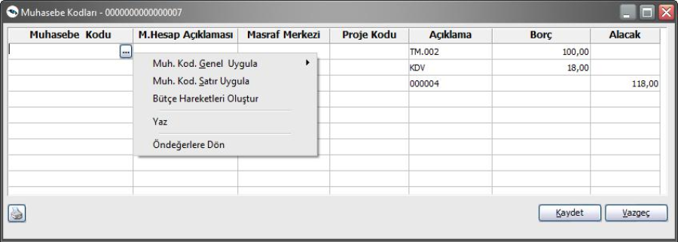
With the option of accounting connection codes;
A second method is to use the Accounting Connection Codes option. Accounting Connection Codes are located under the Accounting menu.
It is possible to determine whether the codes given here will be transferred to the cards by default and to ensure their transfer if necessary. For this, selection is made in the default filter line.
While defining the accounting codes that will be valid in the accounting of the transactions, the desired number of definitions can be made for each transaction of the cards. In the relevant section, Accounting connection codes are determined in filter lines in the relevant section, where the defined accounting codes will be valid for the accounting of the transactions of which cards.
Note: When the definition is made from the accounting connection codes, when the new card is opened with the same features, the accounting code in the card can be updated. Thus, it will not be necessary to re-enter the accounting code in the card and define each card.
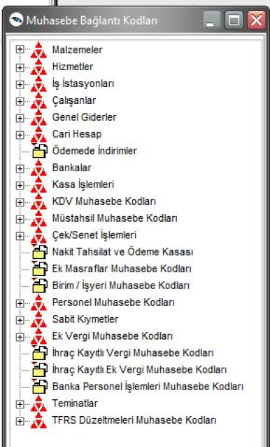
Giving connection codes
While defining the accounting codes, any number of definitions can be made for each transaction of the cards. When Yes is selected in the default filter, which is one of the accounting connection codes filters, the given accounting code is transferred to the cards and transactions by default. If no is selected, the given accounting code will not be transferred to the cards and transactions by default.
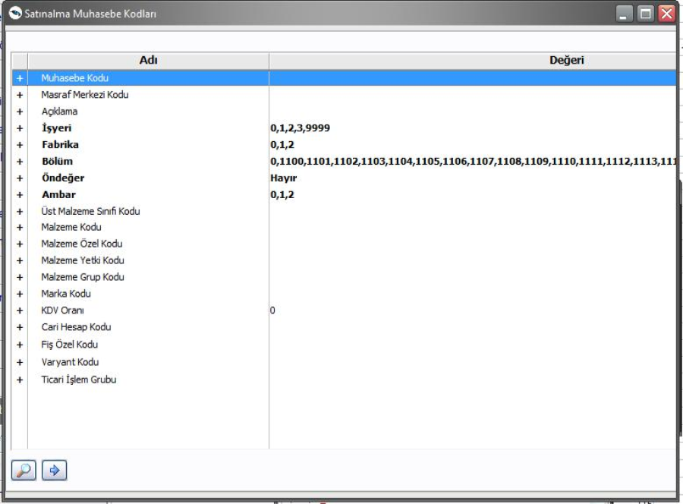
It should be noted that a single default can be defined for each connection code. However, in VAT accounting codes, a default is defined for each VAT rate. In this case, VAT rate condition will be taken into consideration only in the defaults defined for the relevant VAT.
Accounting connection codes are given separately for each card or transaction. If the transactions of the cards are monitored under more than one accounting account, it is possible to define the desired number of connection codes and determine which card or transaction will be valid by determining the conditions in the filter lines on the relevant definition screen. Each definition made is listed with the card code, special code, accounting code and cost center code in the list of relevant accounting codes.
Selection of transactions to which accounting codes will be given
After the selection of the cards to which the accounting codes will be given, the transactions made from the program sections are listed using these cards and the accounting codes to be taken into account in accounting are given.
It is possible to define the desired number of connection codes for each process and to determine the conditions under which these connection codes will be valid. For this, the required conditions are determined in the filter lines in the relevant accounting codes window and the provided accounting codes are only valid for transactions that comply with these conditions.
The Add option is used in the list of relevant accounting connection codes to give the accounting codes and to determine which conditions will be valid for which cards.
Besides the accounting codes, the cost center to which the transaction belongs is determined together with the accounting connection codes. The accounting code that will be valid for the transaction is given in the G / L code filter line in the relevant G / L codes window. The account plan is listed and the relevant account is selected and transferred to the definition field. Under which accounting account, which transactions belonging to which cards are determined in other filter lines.
Transfer of accounting codes to cards and transactions by default
It is possible to determine whether the specified connection codes will be transferred to the cards and transactions by default. For this, selection is made in the default filter line.
Selecting the cards to which the accounting codes will be valid
If the given accounting code will be valid for the transactions of which cards, in the relevant accounting codes window, the cards to which the accounting codes will be valid are determined by defining the group or range in the code and special code field (material, current account, bank). After determining the condition in filter lines, the definition made is saved and the list of relevant accounting codes is returned.
Application of Connection Codes
In the program sections, the lines of the offset receipt that will occur as a result of the accounting in the F9 menu, both on the receipt and in the receipt lists, are displayed as a table.
In the G / L codes window, it is possible to apply G / L codes in G / L connection codes for the receipt or receipt line. For this, the options in the Transactions list in the Accounting Codes window are used.
Application of accounting codes to receipts
Accounting codes are applied across the receipt with the Apply accounting codes general option in the F9 right mouse button menu. Accounting codes can be applied only for connections that are empty, as well as for all codes. When the accounting is done, the offset receipt that appears will be displayed in a table. If any transaction in the receipt is to be monitored under a different accounting account, it can be changed. In this case, only the transaction entered with this voucher will be accounted under the accounting code given here.
Application of accounting codes to the line
Accounting codes can be applied across the receipt as well as on the desired lines in the receipt. In order to apply the accounting codes to the line, the Apply accounting codes line option in the F9 right mouse button menu is used.
In this case, the accounting codes are applied only to the transaction in the selected line and the offset to be cut is displayed when the accounting is performed.
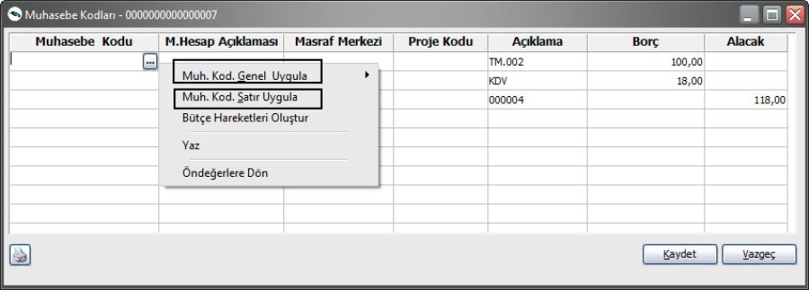
Material Cards Accounting Connection Codes
It is the option that G / L account codes are given to track the transactions of material cards when accounting. Purchase, sale, other entry and exit, waste, consumables, entry from production, user-defined entry and exit receipts, purchase costs, sales costs, purchase discounts, sales discounts, promotions received, promotions given, promotional VAT expense account, purchase and sales return accounting codes are given by selecting the relevant menu headings. Whether accounting codes and expense centers connection codes, which will be valid for each transaction, will be transferred to the cards by default in the accounting windows when issuing the accounting codes. Connection codes filter options are as follows.
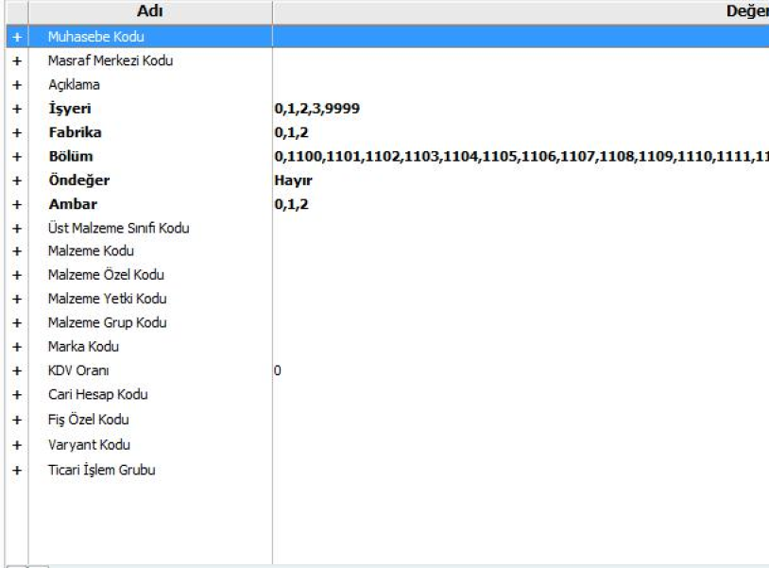
Service Cards Accounting Connection Codes
It is the option that the accounting account codes are given to be followed when accounting for the transactions of the service cards. Service codes received, given, service discounts, expenses and promotions, and service returns received and given are given by selecting the relevant menu headings. Whether accounting codes and expense centers connection codes, which will be valid for each transaction, will be transferred to the cards by default in the accounting windows when issuing the accounting codes. Connection codes filter options are as follows.
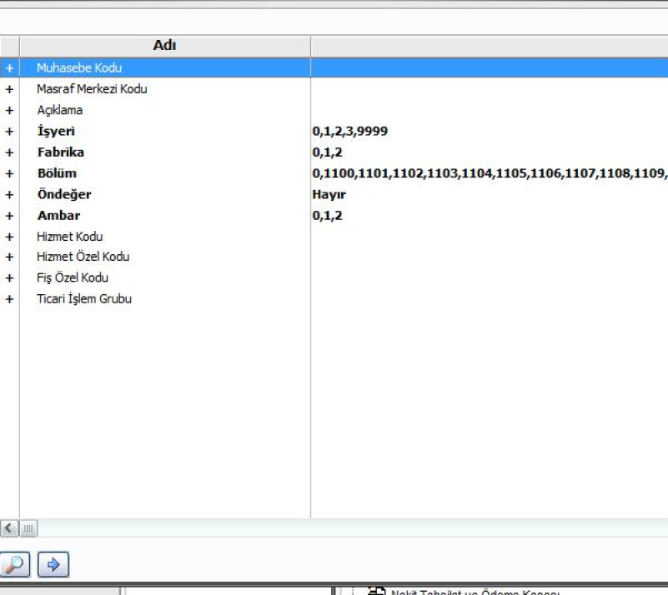
Current Account Cards Accounting Connection Codes
It is the option that the accounting account codes are given to be followed when the accounting of the transactions of the current account cards is performed. Whether accounting codes and expense centers connection codes, which will be valid for each transaction, will be transferred to the cards by default in the accounting windows when issuing the accounting codes. Connection codes filter options are as follows.
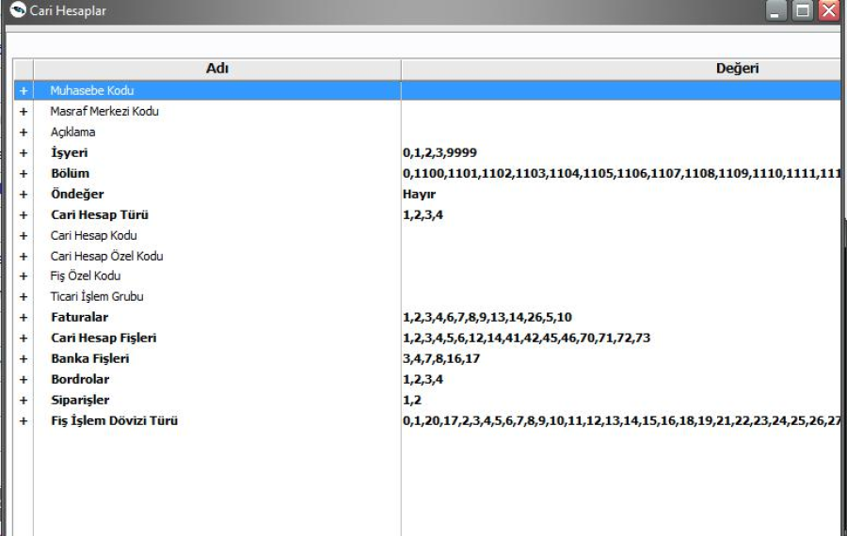
Discounts on Payment Accounting Connection Codes
It is the option where the accounting account codes are given, which will be used to monitor the transactions of discounts in the payment. Whether accounting codes and expense centers connection codes, which will be valid for each transaction, will be transferred to the cards by default in the accounting windows when issuing the accounting codes. Connection codes filter options are as follows.
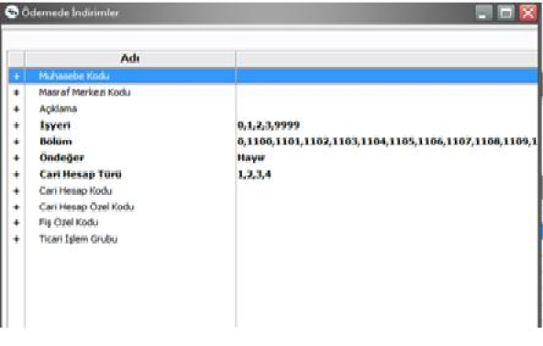
Debit Cards Accounting Connection Codes
It is the option that the accounting account codes are given to be followed when the accounting of the transactions of the bank cards is performed. Account codes of the bank's current accounts, clearing checks, collection bills, issued checks, collateral bills, collateral checks, credit for promissory notes, credit transactions against checks are selected by selecting the relevant menu headings. Whether accounting codes and expense centers connection codes, which will be valid for each transaction, will be transferred to the cards by default in the accounting windows when issuing the accounting codes. Connection codes filter options are as follows.
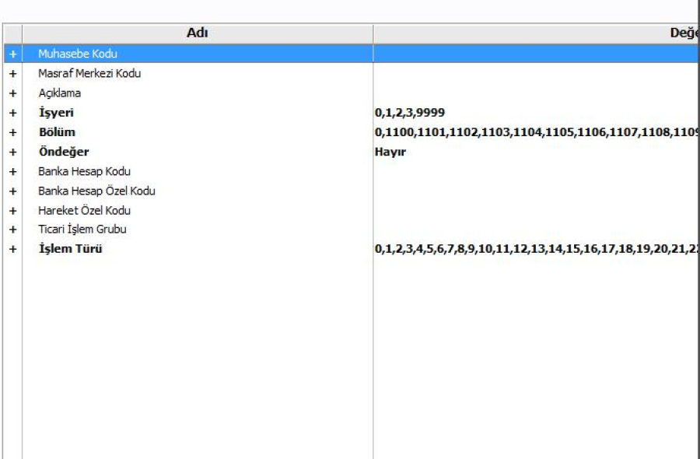
Cash Cards Cards Accounting Connection Codes
It is the option that the accounting account codes are given, which will be followed when the accounting of the transactions of the cash cards. Whether accounting codes and expense centers connection codes, which will be valid for each transaction, will be transferred to the cards by default in the accounting windows when issuing the accounting codes. Connection codes filter options are as follows.
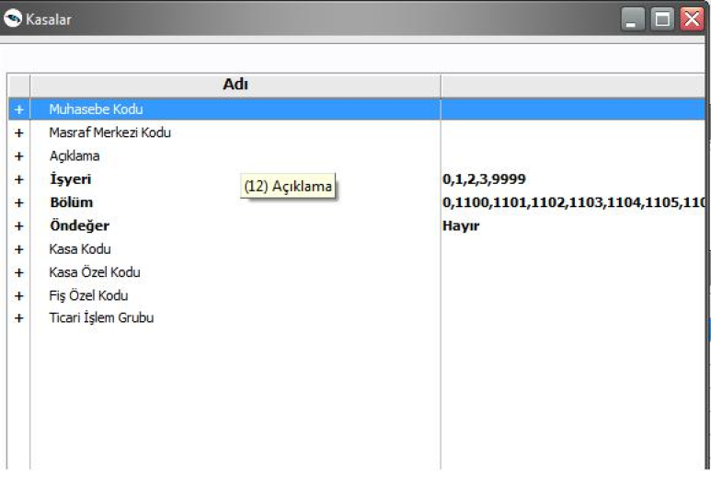
Recognition
Accounting slips that must be recorded for transactions made in program sections other than accounting are created directly by the accounting process. Accounting transactions are extremely easy especially in enterprises with intensive daily activities and time loss is prevented.
Accounting account codes that will be monitored when the cards opened in all program sections and their transactions are tracked, are determined by giving the accounting connection codes. The accounting connection codes that will be valid in the accounting process are given through the cards in the relevant program sections or the Accounting connection codes option in the Accounting section.
When performing transactions in the program sections, the Accounting Codes option is applied with the Accounting Codes option, or the accounting codes are applied only for the transaction in the line and the offset receipt that will occur when the accounting is performed is displayed.
Accounting process;
• from the accounting program department
• From the receipt and invoice list in the relevant program sections
It is done in two ways.
How to perform the transaction in the Accounting parameters window is determined before performing the accounting. Accounting process is started with the OK option.
If Yes is selected in the G / L control filter line, every receipt created is displayed and saved after it is checked.
There may be transactions that are accounted for but are not intended to generate an offset slip. In this case, the Mark option is used on the offset slip generated by the accounting transaction. The transaction is accounted for but the resulting offset is not included in the accounting records and does not affect the accounting accounts.
If the Accounting sign is selected to be Marked in the filter line in the G / L parameters, it is listed with the letter M, which indicates that it is recognized next to the receipt or invoice.
When changes are made to the receipts or invoices that are recognized, the program displays a warning message stating that the transaction has been recognized.
Accounting Filters
Accounting of transactions performed in other program sections is done with the Accounting option under the Operations menu. Accounting, Material, Sales and Distribution Transactions, Financial transactions, Check / Note and Bank are made separately for the transactions made in the program sections.
First, it is selected which accounting department to perform the accounting for the transactions. Under which conditions the accounting will be made, Material, Sales / Purchasing, Financial transactions (current, check / bond and bank) are determined in the accounting filter lines. Generally, the filters used in transferring all program transactions to accounting are as follows:
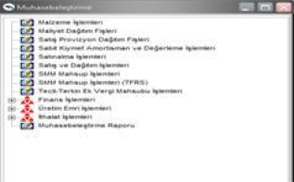
Date range: In this filter line, the transactions between which dates are determined. The start and end date range is given.
Workplace number: It is used to account for the transactions made in the program sections according to the workplaces. The workplaces to be accounted for are selected by marking.
Department number: It is used to account for the transactions made in the program sections according to the department performing the transaction. The relevant section or sections are determined by marking them.
Receipt or transaction type: It is used to account for transactions performed in program sections according to receipt or transaction types. In this filter line, the relevant receipt types are listed according to the accounting transactions. The types of slips to be accounted for are selected by marking them.
Voucher or transaction number: It is used to filter the transactions to be accounted according to the voucher or transaction numbers. A group or range is defined and which receipts to consider are determined.
Voucher or transaction specific code: Slips belonging to certain transactions can be selected from the voucher types, and filtering according to voucher or transaction special code ensures that only transactions with vouchers with the specified special code are recognized. In the slip Special code line, the group or range definition is made and the slip special code is accounted for in this range.
Voucher or transaction authorization code: Vouchers of certain transactions can be selected from the voucher types, as well as filtering according to voucher or transaction authorization code, and only transactions with vouchers with the specified authorization code are recognized. Group or range is defined in the voucher authorization code line.
Accounting method: In this filter line, it is determined how the accounting will be performed. There are three options: General, by Workplace and One to One.
When the transactions that fall within the date range given in the G / L line in the general selection are recognized, a single offset is generated. Transactions recorded in the program section, which is accounted for in the selection of workplaces, are accounted according to the workplaces. Separate offset receipts are created for transactions per business.
On the lawn, each transaction is transferred to accounting with a separate offset slip.
Accounting control: With the accounting process, the transactions made in the program sections are transferred to the accounting and the offset is automatically generated by the program. If it is desired to display the offset slips generated during the accounting process one by one and save them after checking, the To do option must be selected in this filter line. In this case, every offset created is displayed. It is saved after review.
If the option not to be made is selected, the receipts generated as a result of the accounting are marked directly in the relevant sections and written to the accounting file.
Accounting Sign: The marking of the transactions that are transferred to the accounting and the accounting process, and in case of a new accounting transaction of the same dates, are not taken into consideration by the selection to be made in this filter line. The filter line has two options, with and without marking. In the program, the line that will be marked as default is selected. At the end of the accounting, these transactions are listed in the program sections with the letter M indicating that they have been recognized.
If it is not desired to mark the transactions transferred to accounting, it is selected not to be marked. In this case, accounting transactions are not marked.
Line consolidation: The line combining filter line determines how the lines that belong to the same card and the same accounting link code are recognized in the slips that are recognized. It has two options, yes and no. When selecting Yes, the lines belonging to the same card within the same receipt and to be monitored under the same accounting account codes will be accounted to be combined.
General Description of the Accounting Slip: The content of the offset general statement to be generated as a result of the accounting is determined in this filter line. The filter has two options: to be re-created and to be generated from the G / L slip. In the selection that will come from the receipt recognized, the explanation entered for the receipt is transferred to the offset receipt exactly.
Accounting Receipt line description: It is used to create descriptive lines in the accounting receipts that will occur as a result of the accounting process. Descriptive line that is requested to be displayed in G / L slip is determined with G / L slip line description filter. The fields to be transferred to the G / L slip as line description are listed in the filter. The requested information (transaction number, document number, transaction type, line description, material description, current account title, etc.) is selected by marking.
Accounting Slip General Description: The general description of the offset slip to be generated as a result of the accounting is determined by the selection to be made in this line. It has two options: to be reconstructed and to be generated from the Receipt recognized.
In the selection to be rebuilt, the comment is re-created by the program. In the selection that will come from the receipt recognized, the explanation entered for the receipt is transferred to the offset receipt exactly.
Lines without accounting code: This parameter is used to account for information received from outside to inside. In the absence of accounting account codes in the transfers, it is determined which accounts will be taken into account in the accounting. Parameter line,
- No action will be taken
- To be read from the card
It has two options.
In the selection of not to be processed, lines without accounting code are not taken into account in the accounting process.
In the selection to be taken, the accounting account codes of the transactions are read from the relevant cards in the accounting process and the transactions are transferred to the accounting under the accounting codes given on the card.
Default Evaluation Service:
Accounting code can be assigned to the slips generated for transactions entered before the accounting code definition is made, with the default service in the file menu. In the main menu, the file can be assigned to the Accounting Code by selecting the Default Records and the section where you want to default. The parameters used in the default process are as follows;
Receipt date: The date on which you will assign the accounting code to the receipts is determined.
Receipt Type: The receipt types to be run in default are selected.
Workplace: Related Workplace
Episode: Dependent Sections
Warehouse: Defined Warehouses
Voucher Special Code: Defined voucher special code
Voucher Number: Defined Voucher Numbers
New Accounting Values: It consists of 2 options: Read From Cards, Read From Connection Codes . If read from cards is selected, the accounting codes defined on the cards are taken into consideration. Read from link codes: The default service is run according to the codes defined from the accounting link codes.
Values ​​to Update: Only empty codes are two options as all codes. When only empty codes are selected, it makes assignments only to empty codes without deleting the previously entered accounting codes. All codes option, on the other hand, is deleted from the previously entered accounting codes and reappointment is made by reading the last value from the cards given in filters or connection codes.
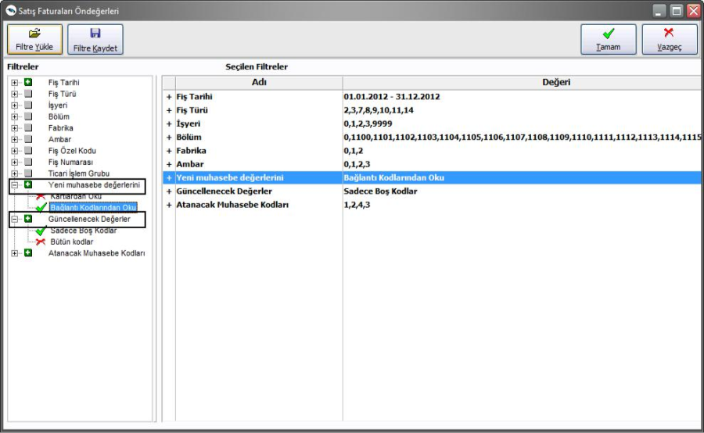
SMM Filter in Invoice Default Process
Accounting codes default service has "Accounting Codes to be Assigned: Invoice / SMM" criteria. Thus, only SMM accounting codes can be evaluated.
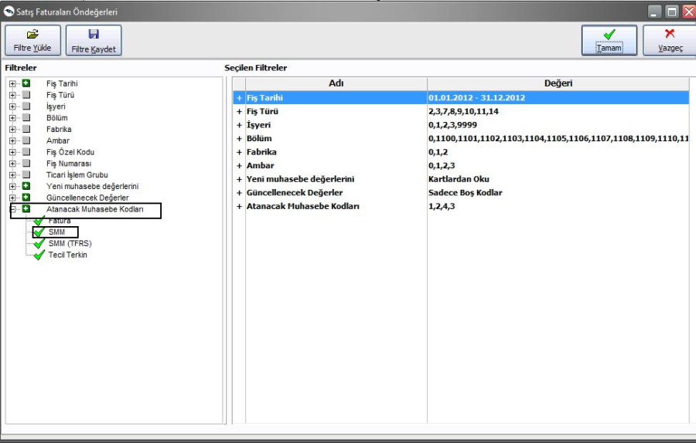
Since the invoice accounting codes and SMM accounting codes are assigned together while performing the default process in sales invoices, invoicing and SMM accounting codes can be assigned at different times in order to avoid performance problems in the default process. Thus, when the number of connection code definition lines is high, the default process can be accelerated.
SMM Accounting
Accounting of the cost of the sold product is a transaction made at the end of the sales transactions. It is performed after the accounting of the sold goods. In other words, the cost of the sold goods cannot be offsetted without the sales invoice being recognized. The offset receipt resulting from this transaction includes the cost of the material.
Cost of sold goods accounting account codes
Accounting account codes to be used in the accounting of the cost of the goods sold
- With SMM Accounting Account Codes option in F9 right mouse button menu on invoice
- With SMM Accounting Codes option in F9 right mouse button menu in Sales Invoices list.
- With Material Cards option in G / L Connection Codes menu in General Ledger section
- It is given with the Accounting Accounts option on the material card.
In the clearing of the cost of the goods sold, lines such as material, mixed parcel, fixed asset and promotion are taken into account. The lines of the type of discount, expense, service, material class in the invoice and the lines that make up the mixed parcel material are not taken into consideration.
Accounting of the cost of the goods sold
The accounting for the cost of the sold goods is done in 2 ways.
- With Create SMM Invoice option in F9 menu in Sales Invoices list
- With the Accounting option under the Transactions menu in the General Accounting program section.
1. Creating an SMM Receipt from the Sales Invoices list
Accounting of the cost of the sold goods is created individually from the list of sales invoices. For this, the Create SMM Offset option in the F9 right mouse button menu is used. This option is only available in the F9 menu on recognized sales invoices.
When Create SMM Receipt is selected, a window opens in which the criteria that will be valid in the offset creation process are determined. The filters in this window are:
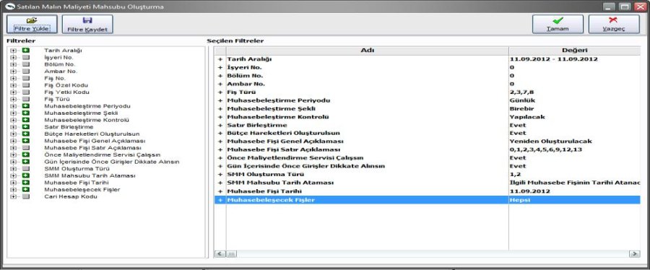
Accounting Control: If the offset slip to be generated as a result of the accounting process is checked and it is desired to record it after checking the G / L check option in the filter line. In this case, each offset receipt to be generated is recorded after the income is examined.
Line Merge: If Do Not Choose in Accounting Control filter, slips are marked directly in the relevant sections and written to the accounting file.
The lines that belong to the same card and the same accounting connection codes are accounted for in the invoiced line are determined by the Line Merge filter. If Line Merge is selected as Yes, the lines belonging to the same card within the invoice to be followed with the same accounting account codes are combined. It is displayed as a single line in the offset receipt to be generated as a result of accounting.
Accounting Slip General Description: The content of the general description of the offset slip to be generated as a result of accounting is determined in the filter line. If it is desired to reproduce the general explanation, it will be selected to be reproduced. The description is created by the program. If it is selected from the receipted slip, the invoice that is recognized is transferred to the offset receipt with the general description.
Accounting Slip line description: Accounting Slip line description filter is used in order to get explanation information to the offset lines to be generated as a result of the accounting process. The information requested to be displayed in the accounting receipt as a line description is selected by marking.
Run costing service first: If it is desired to run the costing service before accounting, yes option is selected in this filter line.
After determining the condition of filter lines, OK button is clicked and SMM creation process is completed.
Voucher or transaction specific code : Slips belonging to certain transactions can be selected from the voucher types, and filtering according to voucher or transaction special code ensures that only transactions with vouchers with the specified special code are recognized. In the slip Special code line, the group or range definition is made and the slip special code is accounted for in this range.
Voucher or transaction authorization code: Vouchers of certain transactions can be selected from the voucher types, as well as filtering according to voucher or transaction authorization code, and only transactions with vouchers with the specified authorization code are recognized. Group or range is defined in the voucher authorization code line.
Accounting control: With the accounting process, the transactions made in the program sections are transferred to the accounting and the offset is automatically generated by the program. If the offset receipts generated during the accounting are requested to be displayed on a single, single screen and saved after being checked, the To option must be selected in this filter line. In this case, every offset created is displayed. It is saved after review.
If the option not to be made is selected, the receipts generated as a result of the accounting are marked directly in the relevant sections and written to the accounting file.
Line consolidation: The line combining filter line determines how the lines that belong to the same card and the same accounting link code are recognized in the slips that are recognized. It has two options, yes and no. When selecting Yes, the lines belonging to the same card within the same receipt and to be monitored under the same accounting account codes will be accounted to be combined.
General Description of the Accounting Slip: The content of the offset general statement to be generated as a result of the accounting is determined in this filter line. The filter has two options, which will be re-created and will come from the receipt recognized. In the selection to be rebuilt, the comment is re-created by the program. In the selection that will come from the receipt recognized, the explanation entered for the receipt is transferred to the offset receipt exactly.
Accounting Receipt line description: It is used to create descriptive lines in the accounting receipts that will occur as a result of the accounting process. Descriptive line that is requested to be displayed in G / L slip is determined with G / L slip line description filter. The fields to be transferred to the G / L slip as line description are listed in the filter. The requested information (transaction number, document number, transaction type, line description, material description, current account title, etc.) is selected by marking.
Accounting Slip General Description : The general description of the offset slip to be generated as a result of the accounting is determined by the selection to be made in this line. It has two options: to be reconstructed and to be generated from the Receipt recognized.
Run costing service first: If it is desired to run the costing service before accounting, yes option is selected in this filter line.
SMM Creation Type: This filter line has two options : Current Costs and Difference Costs. SMM is created for current costs of sales invoices accounted for in the current selection.
In the selection of Difference Costs, if the cost changes for any reason (price differences, etc.) for the sales invoices that have previously been created, the related difference will be created as much as the related difference.
The offset slips resulting from the SMM creation are listed with the document type in the G / L slips list.
The slips formed for current costs are listed with the letter M, and the SMM slips created for the difference costs are listed with the letter F.
Accounting Report
When the accounting is completed, the report is taken. The Accounting report is displayed with the Accounting Report option to examine it later or to remedy the error in case of an error.
Accounting dates and accounting form are listed in the upper part of the report. In the lines, if the error occurs, the receipt of the error is listed with the date, type and error information received. The errors in the connection codes are corrected on the report by clicking on the relevant line.
At the end of the report, the number of documents compiled, number of transactions compiled, totals added and transaction totals are listed.
