[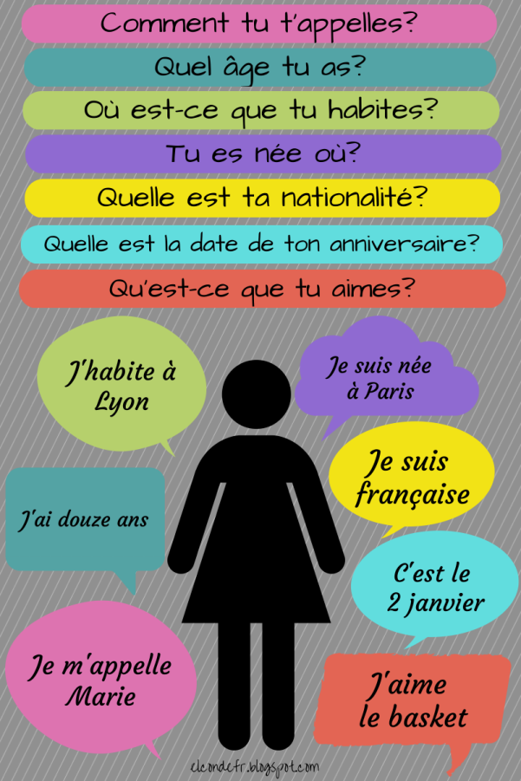](http://www.google.com.tr/url?sa=i&rct=j&q=&esrc=s&source=images&cd=&cad=rja&uact=8&ved=0ahUKEwiboqDU_8zMAhUHCywKHditCo4QjRwIBw&url=http://dansmafrance.blogspot.com/2015/11/se-presenter-et-decrire-quelquun.html&psig=AFQjCNFqgREiw697dJWO5VuUR2x7LtCN9A&ust=1462883444208060)

[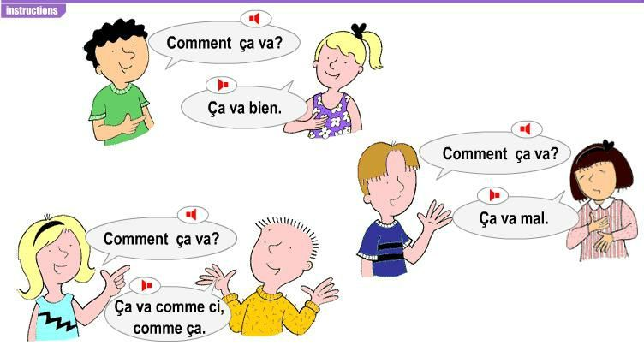](http://www.google.com.tr/url?sa=i&rct=j&q=&esrc=s&source=images&cd=&cad=rja&uact=8&ved=0ahUKEwjekbfy48zMAhVEiSwKHQhKC3gQjRwIBw&url=http://aula.iespjmariana.es/aula/course/index.php?categoryid=25&psig=AFQjCNE7nTZ5_4MrLdMFXOKYO7Apm_HQXw&ust=1462875988331170)