ÇAĞ UNIVERSITY
FACULTY OF ECONOMICS AND ADMINISTRATIVE SCIENCES
Code |  |  |  | Course Title |  |  |  |  |  |  |  |  |  |  |  | Credit |  |  |  |  | ECTS
IRE 310 |  |  |  | Political History of Middle East |  |  |  |  |  |  |  |  |  |  |  | (3-0)3 |  |  |  |  | 6
Prerequisites |  |  |  |  |  |  |  | None
Language of Instruction |  |  |  |  |  |  |  | English |  |  |  | Mode of Delivery |  |  |  |  |  | Face to face/ Webinar
Type and Level of Course |  |  |  |  |  |  |  | Elective, /3.Year/ Spring Semester EQF- Level 5
Lecturers |  |  |  |  | Name(s) |  |  |  |  |  | Lecture Hours |  |  |  |  |  | Office Hours |  |  |  | Contacts
Course Coordinator |  |  |  |  | Dr. Saffet AKKAYA |  |  |  |  |  |  |  |  |  |  |  | Thursdays. 10.00-12.00 |  |  |  | saffetakkaya@cag.edu.tr
Course Objective |  |  |  |  | The primary goal of this course is to analyze the political, economic and social characteristics of the Middle East which occupies an important place in Turkish foreign policy.
Learning Outcomes of the Course |  |  | Students who have completed the course successfully should be able |  |  |  |  |  |  |  |  |  |  |  |  |  |  |  |  | Relationship
 |  |  |  |  |  |  |  |  |  |  |  |  |  |  |  |  |  |  |  | Prog. Output |  |  | Net Effect
 |  | 1 | to describe the Middle East region and the main characteristics of this Region, |  |  |  |  |  |  |  |  |  |  |  |  |  |  |  |  | 2,6 |  |  | 4,5
 |  | 2 | to compare the Middle East countries in view of their powers, |  |  |  |  |  |  |  |  |  |  |  |  |  |  |  |  | 2,6 |  |  | 4,5
 |  | 3 | to analyze the problems of the Middle East region and their effects to Global Politics |  |  |  |  |  |  |  |  |  |  |  |  |  |  |  |  | 9 |  |  | 3
 |  | 4 | to analyze the problems of the relations between the Middle Eastern countries, |  |  |  |  |  |  |  |  |  |  |  |  |  |  |  |  | 2,6 |  |  | 5,4
 |  | 5 | to explain the effects of colonialism upon Middle East countries and societies, |  |  |  |  |  |  |  |  |  |  |  |  |  |  |  |  | 2 |  |  | 5
 |  | 6 | to compare the Middle East politics of the global powers, |  |  |  |  |  |  |  |  |  |  |  |  |  |  |  |  | 9 |  |  | 3
 |  | 7 | to analyze the main characteristics of the Middle East countries and the developments of their domestic politics, |  |  |  |  |  |  |  |  |  |  |  |  |  |  |  |  | 2,6 |  |  | 4,5
 |  | 8 | to explain the developments concerning the Turkish Iran-Iraq-Syria politics |  |  |  |  |  |  |  |  |  |  |  |  |  |  |  |  | 2,6 |  |  | 4,5
 |  | 9 | to analyze the role non-state actors in the region. |  |  |  |  |  |  |  |  |  |  |  |  |  |  |  |  | 2,6 |  |  | 4,5
Course Description: The course will start with an inquiry into the definition of the Middle East region and its political, economic, and societal features. It will then move on to analyze main social, political, and military problems in the region. The course will also cover in detail Turkey’s policy toward the region.
Course Contents:( Weekly Lecture Plan )
Weeks | Topics |  |  |  |  |  |  |  |  |  |  |  | Preparation |  |  |  |  |  | Teaching Methods
1 | Where is the Middle East, the importance of the ME in global politics. |  |  |  |  |  |  |  |  |  |  |  | Textbook |  |  |  |  |  | Presentation & Lecture  audio-visual assisted
2 | The making of modern Middle East, Colonialism and its effects. |  |  |  |  |  |  |  |  |  |  |  | Textbook |  |  |  |  |  | Presentation, & Lecture  audio-visual assisted
3 | The end of empires: the emergence of the modern Middle Eastern states. |  |  |  |  |  |  |  |  |  |  |  | Textbook |  |  |  |  |  | Presentation, & Lecture  audio-visual assisted
4 | Arab nationalism, Arab unity and the practice of intra-Arab state relations |  |  |  |  |  |  |  |  |  |  |  | Textbook |  |  |  |  |  | Presentation & Lecture  audio-visual assisted
5 | The growth of state power in the Arab world:  the single-party regimes, family rules. |  |  |  |  |  |  |  |  |  |  |  | Textbook |  |  |  |  |  | Presentation & Lecture  audio-visual assisted
6 | The social structure of Middle Eastern countries, role of clans, tribes, sects. |  |  |  |  |  |  |  |  |  |  |  | Textbook |  |  |  |  |  | Presentation & Lecture  audio-visual assisted
7 | Midterm Exam |  |  |  |  |  |  |  |  |  |  |  | Textbook |  |  |  |  |  | Presentation & Lecture  audio-visual assisted
8 | The economic structure of Middle Eastern countries, the rentier state reality.(Owen-Pamuk) |  |  |  |  |  |  |  |  |  |  |  | Textbook |  |  |  |  |  | Presentation & Lecture  audio-visual assisted
9 | Great power politics in the Middle East, Status-qua vs Revisionism. |  |  |  |  |  |  |  |  |  |  |  | Textbook |  |  |  |  |  | Presentation & Lecture  audio-visual assisted
10 | Parties, elections and the problematic question of democracy in the Arab world |  |  |  |  |  |  |  |  |  |  |  | Textbook |  |  |  |  |  | Presentation & Lecture  audio-visual assisted
11 | Global Political Islam and the Middle East  (Mandaville, 50-95) |  |  |  |  |  |  |  |  |  |  |  | Textbook |  |  |  |  |  | Presentation & Lecture  audio-visual assisted
12 | The role of Violent non-state actors in the Middle East |  |  |  |  |  |  |  |  |  |  |  | Textbook |  |  |  |  |  | Presentation & Lecture  audio-visual assisted
13 | Turkey Iran-Iraq-Syria Relations |  |  |  |  |  |  |  |  |  |  |  | Textbook |  |  |  |  |  | Presentation & Lecture  audio-visual assisted
14 | Final Exam |  |  |  |  |  |  |  |  |  |  |  | Textbook |  |  |  |  |  | Presentation & Lecture  audio-visual assisted
REFERENCES
Textbook |  |  |  |  |  | State, Power and Politics in the Making of the Modern Middle East, Roger Owen 2006, A history of Middle East Economies in the Twentieth Century, Roger Owen & Şevket Pamuk, 1998, Global Political Islam, Peter Mandaville 2007.
Recommended Reading  Related links |  |  |  |  |  | Arthur Goldschmidt Jr., A Concise History of The Middle East, West view Press, Oxford 2010  Camron Michael Amin vd., The Modern Middle East, Oxford University Pres, Oxford 2007.
Material Sharing |  |  |  |  |  | Presentation Slides
ASSESSMENT METHODS
Activities |  |  |  |  |  |  | Number |  |  | Effect |  |  |  | Notes
Midterm Exam |  |  |  |  |  |  | 1 |  |  | 30%
Homework |  |  |  |  |  |  | 1 |  |  | 10%
Performance |  |  |  |  |  |  | 1 |  |  | 10%
Effect of The Activities |  |  |  |  |  |  |  |  |  | 50%
Effect of The Final Exam |  |  |  |  |  |  | 1 |  |  | 50%
ECTS TABLE
Contents |  |  |  |  |  |  |  |  | Number |  |  |  |  |  | Hours |  |  |  |  |  |  | Total
Hours in Classroom |  |  |  |  |  |  |  |  | 14 |  |  |  |  |  | 3 |  |  |  |  |  |  | 42
Hours out Classroom |  |  |  |  |  |  |  |  | 14 |  |  |  |  |  | 4 |  |  |  |  |  |  | 56
Midterm Exam |  |  |  |  |  |  |  |  | 1 |  |  |  |  |  | 20 |  |  |  |  |  |  | 20
Homework |  |  |  |  |  |  |  |  | 1 |  |  |  |  |  | 20 |  |  |  |  |  |  | 10
Performance |  |  |  |  |  |  |  |  | 1 |  |  |  |  |  | 20 |  |  |  |  |  |  | 10
Final Exam |  |  |  |  |  |  |  |  | 1 |  |  |  |  |  | 40 |  |  |  |  |  |  | 40
Toal  Total / 30  ECTS Credit |  |  |  |  |  |  |  |  |  |  |  |  |  |  |  |  |  |  |  |  |  | 178
 |  |  |  |  |  |  |  |  |  |  |  |  |  |  |  |  |  |  |  |  |  | =178/30=5,9
 |  |  |  |  |  |  |  |  |  |  |  |  |  |  |  |  |  |  |  |  |  | 6
RECENT PERFORMANCE
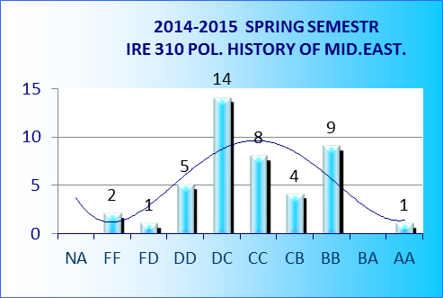 | 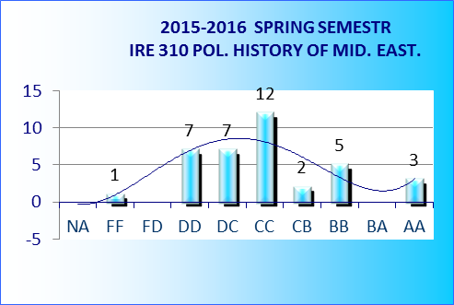
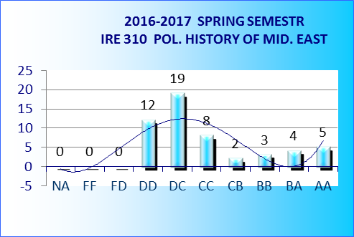 | 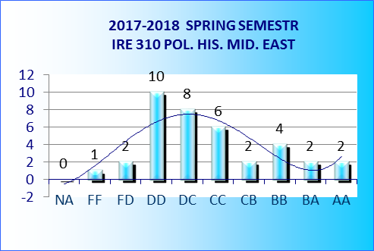
 | 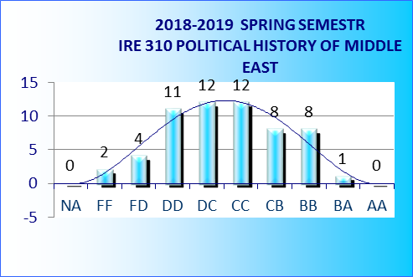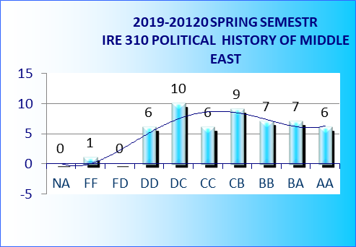

Wednesday  13.25-15.45 | Perşembe 10.00-12.00

