QUESTİON 1:
Company A has the following financial situation at the beginning of 2011, create the opening slip in LOGO according to Turkish Uniform Codes:
Cash: 10.000 TL
Banks:20.000 TL
Debt to Suppliers: 40.000 TL
Credits to Banks with maturity less than 1 year: 10.000 TL
Receivables: 100.000 TL
Machines for production: 150.000 TL
Accumulated Depreciation: 10.000 TL
Credits to Banks with maturity more than 1 year: 10.000 TL
Capital: 20.000 TL

ANSWER:
General Ledger -> Transactions -> GL Slip -> Opening Slip
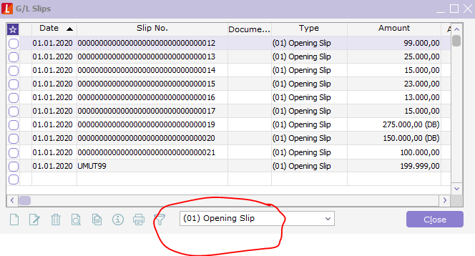
Right Click -> New
Fill in the fields of Account Code, Debt and Credit, with the following information:
Debt |  | Credit
100.Kasa | 10.000 | 300. Banka Kredileri: | 10.000
102. Bankalar | 20.000 | 320. Satıcılar: | 40.000
120. Alıcılar: | 100.000 | 400. Banka Kredileri: | 10.000
253 TMC: | 150.000 | 500. Sermaye: | 20.000
 |  | 570. Geçmiş Yıl Karları | 210.000
 |  | 257 B. Amort: | -10.000
 | 280.000 |  | 280.000
QUESTİON 2:
Create an AR Account with the following information:
Code: 120.03.002
Name of the company: UNIFORM COMPANY
Opening Balance: 60.000 TL
City: Mersin
Town: Tarsus
TR ID Number: 125125698
Discount Rate: 5 to Line

Step1:
Finance -> Main Records - > AR / AP
From drop down menu, choose “CU (Customer)”
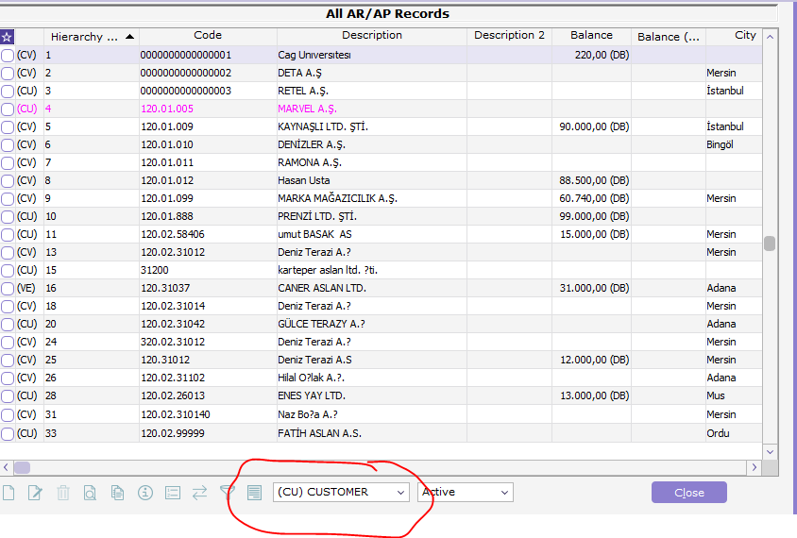
Right Click -> new

Enter the following information on Communication tab:
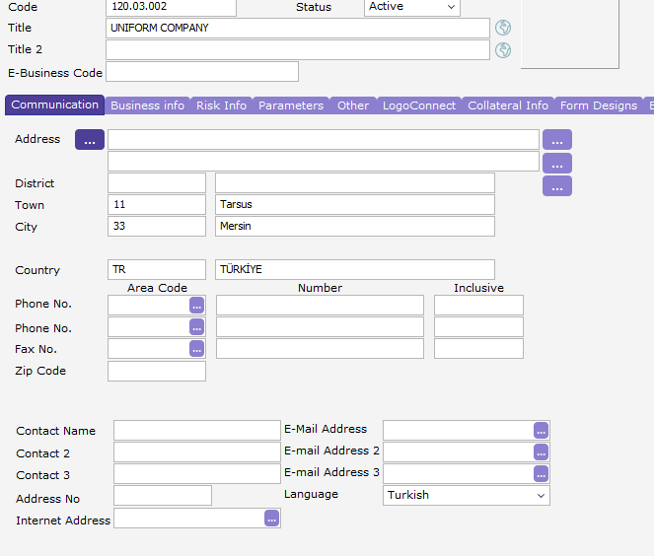
Enter the following information on Business Info tab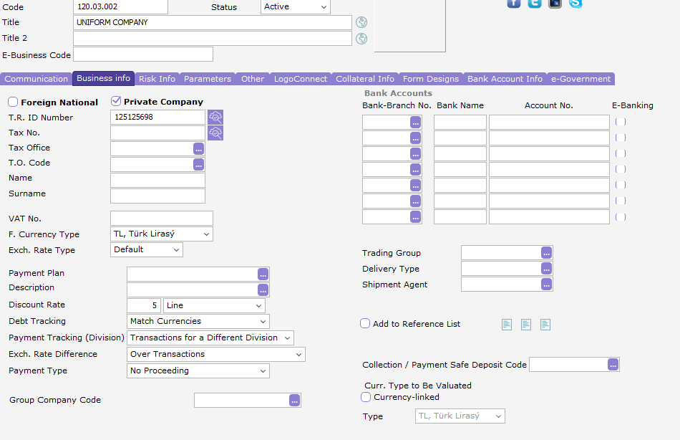

STEP 2:
General Ledger -> Main Records -> GL accounts
Right Click on 120.02 to create 120.03 -> Copy
Account Code : 120.03 -> Save

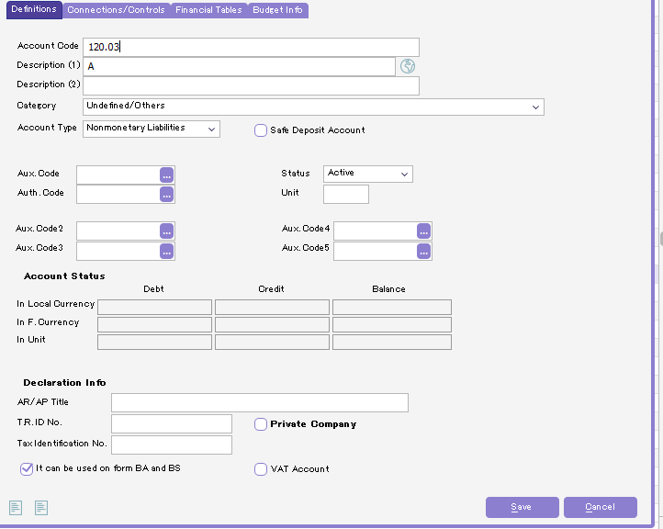

Click on 120.03-> Copy
Account Code: 120. 03 .002
As this account will be declared on BA and BS form, click on “It can be used on Form Ba and BS”
Description: UNİFORM COMPANY -> Save

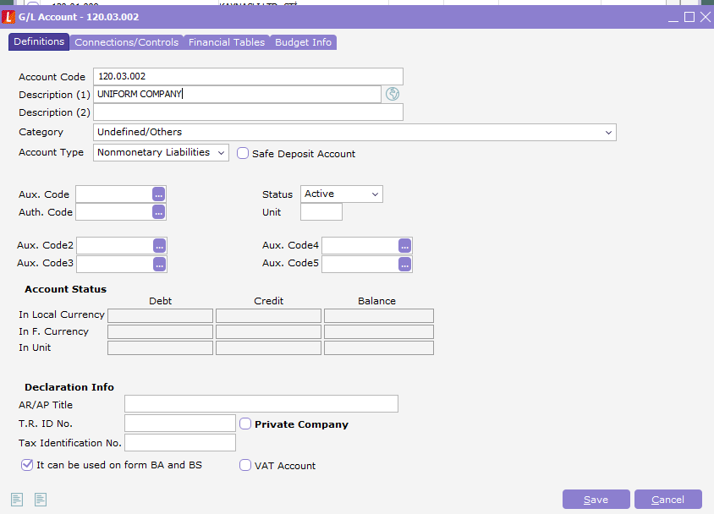
STEP 3:
Finance -> Main Records -> AR/AP -> Other
Right Click on UNIFORM COMPANY -> Update -> Other TAB
In order to make the accounting connection choose Account Code: of 120.03.002 -> Save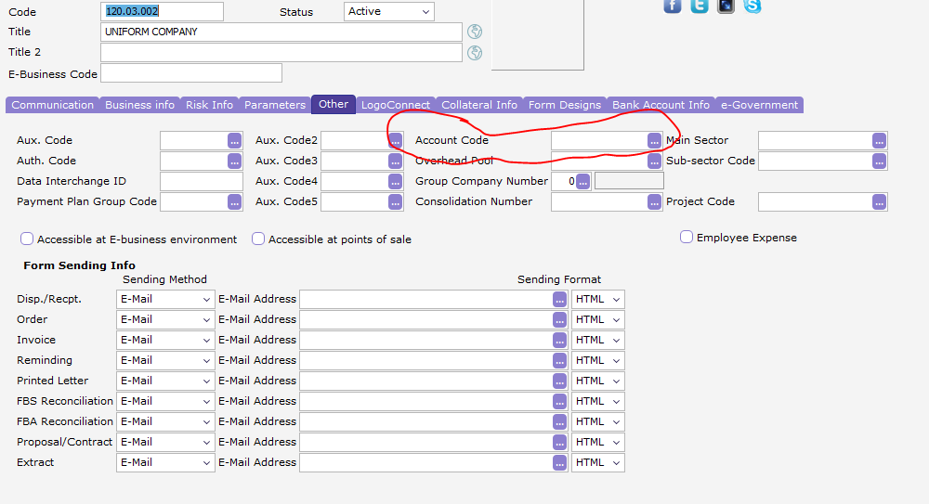
STEP 4:
Finance -> Transactions ->AR / AP slip
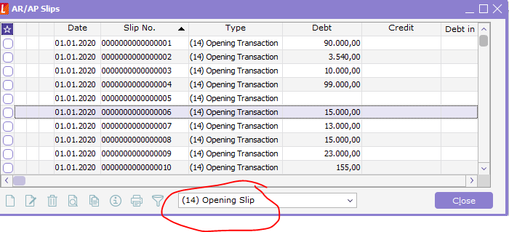
Opening Slip -> Right click New
On AR/Apt tab click (…)

Choose UNIFORM COMPANY.
Enter the debt amount as 60.000 ->enter, (as this is an AR account we entered the debt information)
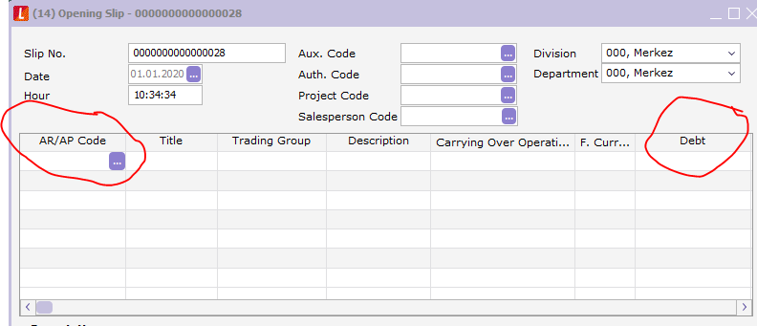
STEP 5:
General Ledger -> Transactions -> GL Slip -> Opening Slip

Enter the following information and save:
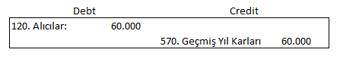
QUESTION 3:
Do the same with on an AP account, [320.03. your school number last 5 digits].
Name the company with a famous brand, its balance should be between 200.000 TL and 500.000 TL.

