**ANSWER KEY**

1. What the major instruments traded in the capital market are ?

**Answer:** capital market instruments are;

* Corporate stock
* Mortgages
* Corporate bonds
* Treasury bonds
* State and local government bonds
* U.S. government agency bonds
* Bank and consumer loans.

1. What is the difference between primary markets and secondary markets?

**Answer:** Primary market: A market in which users of funds (e.g., corporations) raise funds through new issues of financial instruments, such as stocks and bonds.

Secondary market: A market that trades financial instruments once they are issued.

1. What are the services performed by financial institutions?

**Answer:**Services Benefiting Suppliers of Funds:

* Monitoring costs
* Liquidity and price risk
* Transaction cost services
* Maturity intermediation
* Denomination intermediation

Services Benefiting the Overall Economy:

* Money supply transmission
* Credit allocation
* Intergenerational wealth transfers
* Payment services

1. Who are the main fund suppliers of loanable funds ?

**Answer:**

* Households
* Business-nonfinancial
* Business financial
* Government units
* Foreign participants

1. What are the factors that effects the demand of loanable funds?

**Answer:**

* Interest rate
* Utility drived from asset purchased with borrowed funds
* Restictivess of nonprice conditions
* Economic condition

1. If the total wealth increases what happenes to the equilibrium interest rate ? Please show it on graph and explain.

**Answer:** As the total wealth of financial market participants (households, businesses, etc.) increases, the absolute dollar value available for investment purposes increases. Accordingly, at every interest rate, the supply of loanable funds increases, or the supply curve shifts down and to the right.

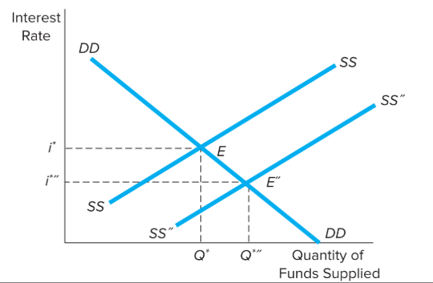

1. A 15-payment annual annuity has its first payment in nine years. If the payment amount is $1,400 and the interest rate is 7 percent, what is the most you should be willing to pay today for this investment?

**Answer:** PV (7%, 15, -1400) =12.751

PV (7%, 9, 12.751) = 6.935 TL.

PV(7%,15,-1400, 1) =**7.421,24 TL**

1. You buy a car for $38,000. You agree to a 60-month loan with a monthly interest rate of 0.55 percent. What is your required monthly payment?

**Answer:** PMT( 0.55%,60,-38000)= **745,29 TL**

1. Suppose you can save $2,000 per year for the next ten years in an account earning 7 percent per year. How much will you have at the end of the tenth year if you make the first deposit today?

**Answer:** FV(7%, 10,2000, 1) =**29.567,20 TL**

1. An insurance company is trying to sell you a retirement annuity. The annuity will give you 20 payments with the first payment in 12 years when you retire. The insurance firm is asking you to pay $50,000 today. If this is a fair deal, what must the payment amount be (to the dollar) if the interest rate is 8 percent?

**Answer:**

FV(8%,12,-50000) =12.908,51

PMT (8%, 20, 12.908,51, 1) = **11.874 TL**

A.GÖKHAN SÖKMEN