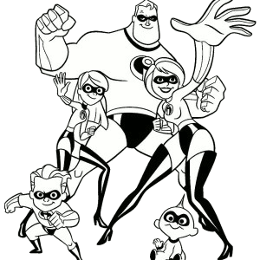

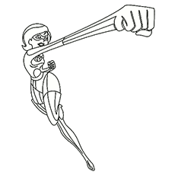

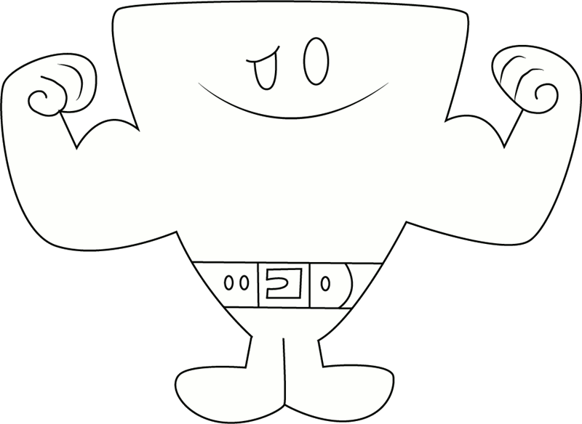
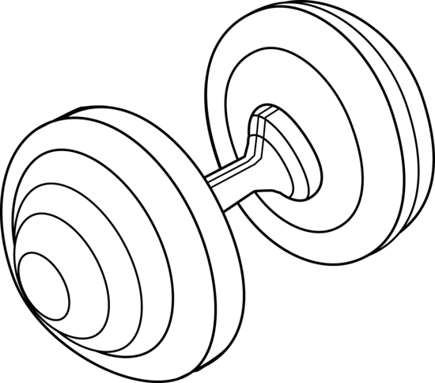


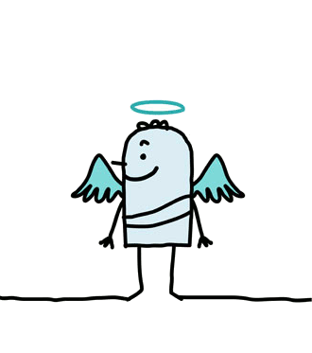




S | B | A | Y | I | N | G | S | O | C | C | E | R
G | I | I | D | R | A | O | B | E | T | A | K | S
U | G | L | R | A | P | O | T | G | N | I | O | G
L | G | L | L | G | N | I | C | N | A | D | I | N
P | E | O | W | I | S | T | H | G | N | I | R | I
E | S | R | D | J | E | E | O | Y | P | G | U | T
T | T | E | S | V | N | S | C | E | I | I | P | S
H | R | O | W | O | R | S | T | T | A | E | N | E
E | E | I | B | N | I | Q | S | A | I | T | L | K
P | A | K | I | R | N | I | E | S | E | M | B | A
S | R | O | Y | M | G | A | B | D | 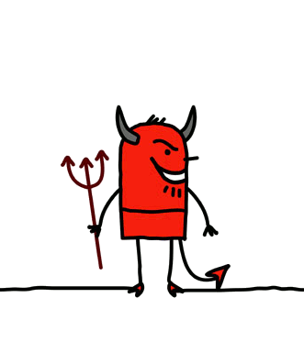K | R | W | E
A | D | X | B | M | I | 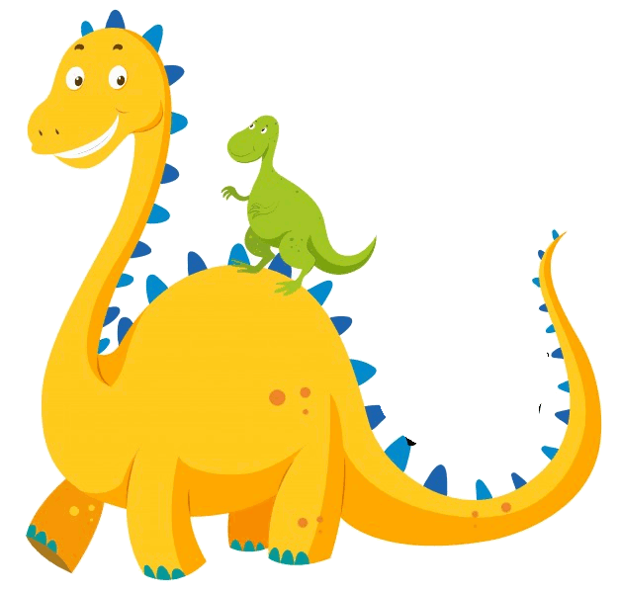S | A | G | J | Y | T | W
1. Write numbers (1-7) in the order they appear on the text:
2. Answer the questions about the text:

1. Who is the youngest in the family?
2. How old is Dash?
3. Who is the oldest?
4. Who is the most intelligent?

Hi, My name is Violet Parr, I’m 14 years old and I live in the centre of New York. Let me introduce you to my family, I’ll start talking about my youngest brother (1) Jack Jack. He’s only 1 years old, weights only 13 kilos and his main power is shape shifting, it means he can change into different forms. Then, I’ll continue talking about my younger brother (2) Dash. He is 10 years old but he can run faster than anyone in the family but I’m stronger (3) than him. He also has special powers like me. We can become invisible and we have elastic arms (4) but mum says that we can’t use our powers unless we are in danger (5). To finish, I’ll talk about my parents, they are Helen and Bob Parr. My mum is 37 years old and she is the most intelligent (6) in the family my dad is 39 and can lift (7) very heavy things so he’s the strongest. We are a very special family as you can see. Now, tell me about yours, I’m sure that you have a very special family too.

4. Find the superlatives of good, bad, big, silly, weak and young:

3. Write true (T) or False (F):

1. Jack Jack hasn’t got any special powers
2. .Helen is two years younger than Bob.
3. Jack Jack is four years younger than Violet.
4. Violet is the fastest in the family.
5. The strongest in the family is Bob.

S | B
 | I |  |  |  |  |  |  |  |  |  |  | Y
 | G | L |  |  |  |  |  |  |  |  | O
 | G |  | L |  |  |  |  |  |  | U
 | E |  |  | I |  |  |  |  | N
 | S |  |  |  | E |  |  | G |  |  |  | T
 | T |  |  |  |  | S | E |  |  |  |  | S
 |  |  | W | O | R | S | T |  |  |  |  | E
 |  |  |  |  | T |  | S |  |  |  |  | K
 |  |  |  |  |  |  | E |  |  |  |  | A
 |  |  |  |  |  |  | B |  |  |  |  | E
 |  |  |  |  |  |  |  |  |  |  |  | W

