THE VAT WITHHOLDING / DEDUCTION APPLICATION
The VAT withholding application is the payment of the VAT calculated on the price of the delivered goods or services, not partially or completely, by those who deal with these transactions, in part or in full, as a taxpayer.
Within this scope, withholding application can be performed in order-dispatch and invoice transactions by selecting material card in the program. In the same section, definitions are provided for purchasing and selling withholding rates to be entered specifically on the material card.
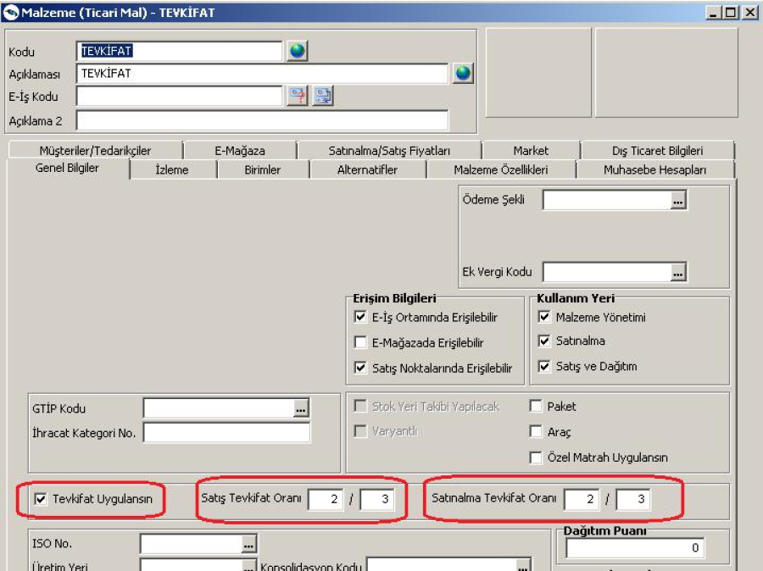
Since a lower limit is based on the law while performing the withholding application, it is also necessary to define the withholding limit and validity date in our programs. Definitions can be made under the heading of Commercial System Management - Definitions - Withholding Limits.
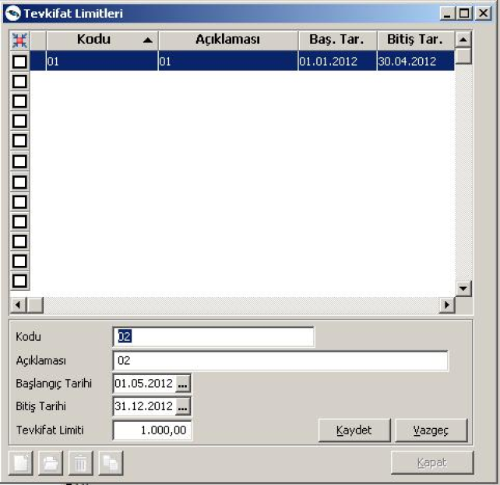
In the Withholding Limit window, the start and end information and the limit number must be entered for the validity date on which the limit control will be made with the add operation.
In the transactions regarding the withholding product, amount control will be carried out within the limit information entered here, and withholding will not be applied for the figures below this limit.
Sample Applications:
Items related to the sales invoice for a withholding amount of 1000 TL:
1000 TL product price
18% VAT - 180
2/3 Withholding - 120
Invoice VAT - 60
Total Amount: 1060 TL
If this invoice is entered in the program, the screenshot below will be reached.
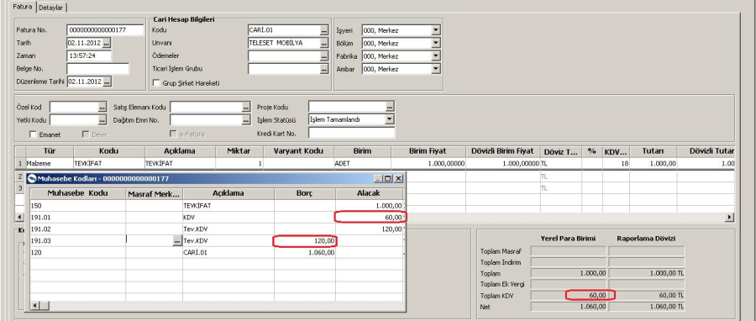
The withholding rates entered in the material card will default to the invoice lines. If desired, the withholding rates can also be changed from the invoice line during the transaction.
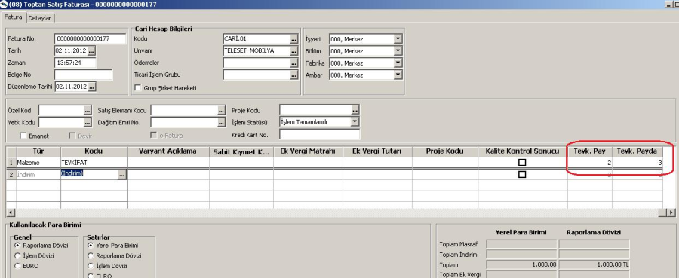
As withholding can be applied within the services as in the material cards, it is possible to perform the operations by checking the check box on the service card in the program. The rate of withholding to be applied within the service card is entered from the card.
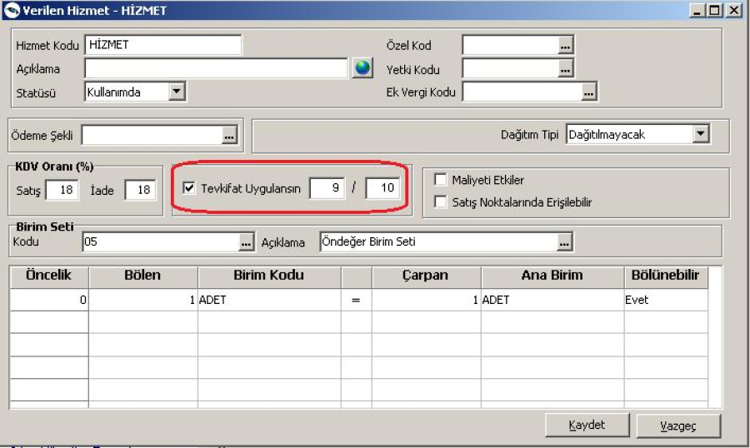
Let's make an application within the definition of service card: When
a service invoice is entered from 18% VAT for a service with a deduction of 1200 TL.
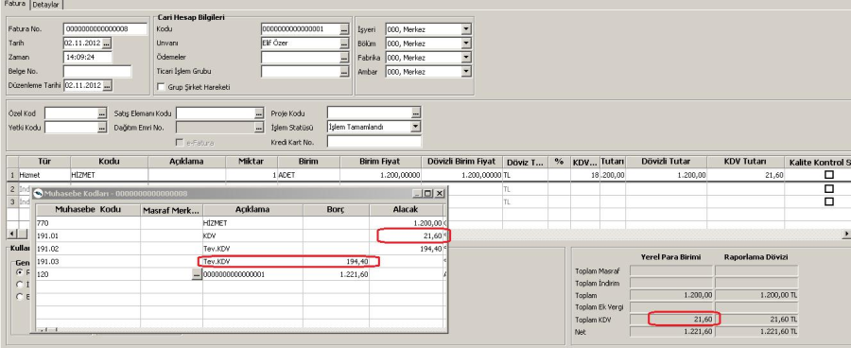
18% VAT for 1200 TL = 216 TL 9/10 Withholding = 194.40 TL
Invoice total will be: 1200 + 21.60 = 1221.60 TL. As there are no figures below the withholding limit we have defined in these examples, VAT withholding took place.
Since our withholding limit is defined as 770 TL between 01.01.2012 - 30.04.2012, let's make our example for a value below the limit in this date range.
Let's make invoice entry for our product with 2/3 withholding amount of 500 TL.
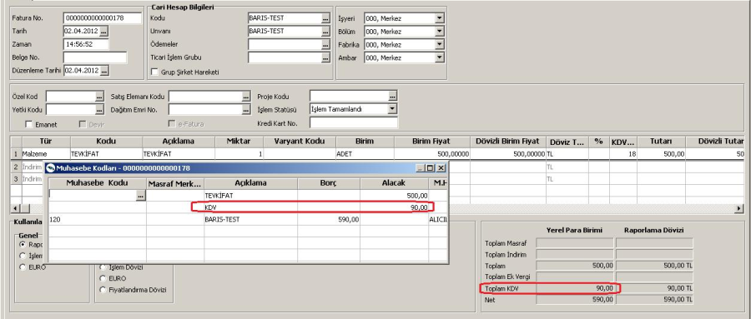
Since the amount of the withholding product is less than the limit of 770 TL, 90 TL with a VAT value of 18% is reflected directly on the invoice.
VAT - REPORTING ACCOUNTING CODES
VAT Accounting Codes should be added from General Accounting - Master Records - Accounting Connection Codes.
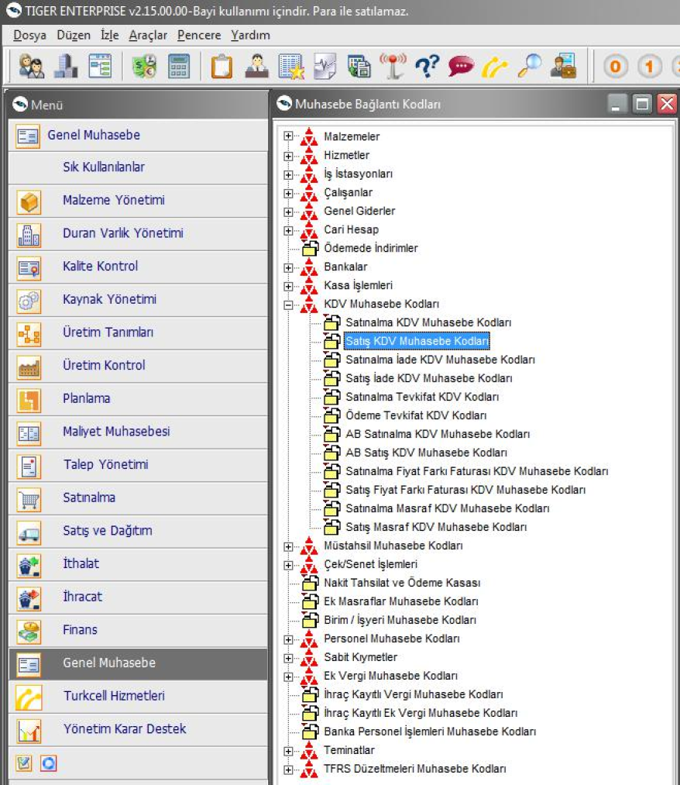
Defining Payment Deduction VAT Accounting Codes
Accounting codes related to withholding can be defined from Payment Deduction VAT Accounting Codes menu. Information such as Accounting Code, Cost Center, Workplace, VAT can be defined.
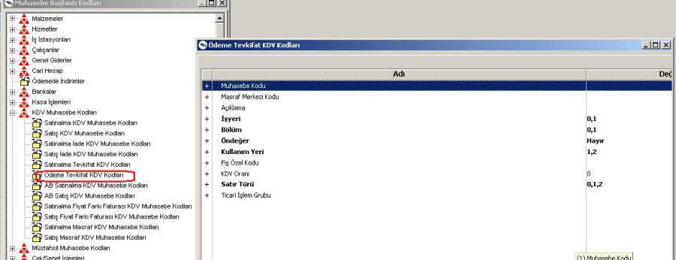
Defining Purchase Withholding VAT Accounting Codes
Purchase Withholding VAT Accounting Codes menu defines purchasing withholding accounting codes. Information such as Accounting Code, Cost Center, Office, VAT can be defined.

