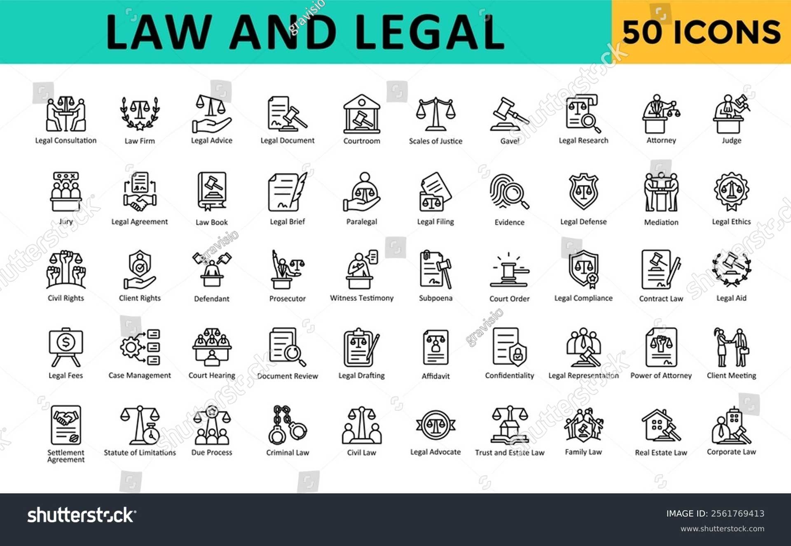

Civil Law

|  |
| --- |
| Civil Law |
| Civil law is a big part of our lives. It's about rules that help us live together peacefully. Imagine a game with rules – that's what civil law is like for our society. Civil law covers things like contracts, property, and family matters. It's different from criminal law, which deals with crimes like theft or assault.  One important part of civil law is the idea of "equal protection." This means that everyone should be treated fairly, regardless of their race, religion, or gender. The Civil Rights Act of 1964 is a great example of this. It made it illegal to discriminate against people based on these things. This law was a big step forward for equality in the United States.  Another important feature of civil law is the right to a fair trial. This means that if you have a disagreement with someone, you can go to court and have a judge decide what's fair. The judge will listen to both sides of the story and make a decision based on the law. This helps to ensure that everyone has a chance to be heard and that justice is served.  Civil law also helps to protect our rights and freedoms. For example, it protects our right to own property, to make contracts, and to get married. It also helps to resolve disputes between people and businesses. Without civil law, our society would be much more chaotic and unfair.  Civil law is constantly evolving to meet the needs of our changing society. New laws are passed and old laws are updated to reflect our values and beliefs. It's important to stay informed about civil law so that we can understand our rights and responsibilities as citizens. |

|  |
| --- |
| Reading Summary |
| * Civil law is like a set of rules that helps us live together peacefully, covering things like contracts, property, and family matters. * Important parts of civil law include equal protection, meaning everyone should be treated fairly, and the right to a fair trial, where a judge listens to both sides of a disagreement and makes a decision based on the law. * Civil law protects our rights and freedoms, like owning property, making contracts, and getting married, and helps resolve disputes between people and businesses. |

Vocabulary

|  |  |  |
| --- | --- | --- |
| Term | Definition | Example Sentence |
| govern (verb) | To control or direct the actions of something or someone. | The laws of the United States govern how we live and interact with each other. |
| obligations (noun) | Things that you are required to do or that you have a duty to do. | When you borrow money from a bank, you have an obligation to pay it back with interest. |
| binding (adjective) | Legally or morally required to be followed. | The contract was legally binding, so both parties had to fulfill their promises. |
| disputes (noun) | Arguments or disagreements between people. | The two neighbors had a dispute over the property line. |
| prohibits (verb) | To forbid or prevent something from happening. | The law prohibits smoking in public places. |
| discriminate (verb) | To treat someone differently, usually unfairly, based on their race, religion, gender, or other personal characteristics. | It is wrong to discriminate against someone because of their skin color. |
| trial (noun) | A formal legal process in which a court of law examines evidence and decides whether a person is guilty of a crime. | The trial lasted for weeks, with both sides presenting their evidence and arguments. |

Multiple Choice Questions

|  |  |  |
| --- | --- | --- |
| Question #1 | Question #2 | Question #3 |
| What is the main difference between civil law and criminal law? | What is the purpose of the right to a fair trial in civil law? | How does the Civil Rights Act of 1964 demonstrate the idea of 'equal protection' in civil law? |
| A. Civil law deals with disagreements between people or businesses, while criminal law deals with crimes like theft or assault.  B. Civil law is more important than criminal law because it affects our daily lives.  C. Civil law is based on the idea of equality, while criminal law is based on the idea of justice.  D. Civil law is about protecting our rights, while criminal law is about punishing people who break the law. | A. To ensure that everyone has a chance to be heard and that justice is served.  B. To make sure that the judge always makes the right decision.  C. To punish people who break the law.  D. To protect the rights of the wealthy and powerful. | A. It made it illegal to discriminate against people based on their race, religion, or gender.  B. It gave everyone the right to vote.  C. It created a new system of courts.  D. It made it easier for people to get jobs. |

Short Answer Questions

|  |  |
| --- | --- |
| Question #1 | What are two examples of topics covered by civil law? |
| __________________________________________________________________________________________________________________________________________________________________________________________________________________________________________________________________________________________________________________________________________________________________________________ | |
| Question #2 | What is the purpose of the right to a fair trial? |
| __________________________________________________________________________________________________________________________________________________________________________________________________________________________________________________________________________________________________________________________________________________________________________________ | |
| Question #3 | How does civil law help protect our rights and freedoms? |
| __________________________________________________________________________________________________________________________________________________________________________________________________________________________________________________________________________________________________________________________________________________________________________________ | |

Open Ended Questions

|  |  |
| --- | --- |
| Question #1 | The text states that civil law is like a game with rules. Think about a game you enjoy playing. What are the rules of that game and how do they help make the game fair and fun for everyone? How is this similar to the way civil law works in our society? |
| __________________________________________________________________________________________________________________________________________________________________________________________________________________________________________________________________________________________________________________________________________________________________________________ | |
| Question #2 | The text discusses the importance of 'equal protection' in civil law. Think about a time when you felt treated unfairly or when you saw someone else treated unfairly. How did that make you feel? How do you think civil law can help ensure that everyone is treated fairly? |
| __________________________________________________________________________________________________________________________________________________________________________________________________________________________________________________________________________________________________________________________________________________________________________________ | |
| Question #3 | The text explains that civil law helps protect our rights and freedoms. Think about some of your most important rights and freedoms. How do these rights and freedoms make your life better? How do you think civil law helps to protect these rights and freedoms for everyone? |
| __________________________________________________________________________________________________________________________________________________________________________________________________________________________________________________________________________________________________________________________________________________________________________________ | |