ÇAĞ UNIVERSITY
FACULTY OF ECONOMICS AND ADMINISTRATIVE SCIENCES
Code |  |  |  | Course Title |  |  |  |  |  |  |  |  |  |  | Credit |  |  |  |  |  | ECTS
MAN-460 |  |  |  | Entrepreneurship in International Business Management |  |  |  |  |  |  |  |  |  |  | 3 (3-0) |  |  |  |  |  | 6
Prerequisites |  |  |  |  |  |  |  |  | None
Language of Instruction |  |  |  |  |  |  |  |  | English |  |  | Mode of Delivery |  |  |  |  | Online
Type and Level of Course |  |  |  |  |  |  |  |  | Elective /4.Year / Spring Semester, Level 8
Lecturers |  |  |  |  | Name(s) |  |  |  |  |  | Lecture Hours |  |  |  |  | Office Hours |  |  |  |  | Contacts
 |  |  |  |  | Lecturer  Eda Kayhan |  |  |  |  |  | Thurs: 09:40-12:20 |  |  |  |  | Friday:  09.40-12.20 |  |  |  |  | edakayhan@cag.edu.tr
Course Objective |  |  |  |  | This course aims to provide students with information on business plan writing, which is one of the most important needs of entrepreneurs, to provide a business idea development and to make the necessary research, to use techniques and to present it in front of the class
Learning Outcomes of the Course |  |  | Students who have completed the course successfully should be able to |  |  |  |  |  |  |  |  |  |  |  |  |  |  |  |  | Relationship
 |  |  |  |  |  |  |  |  |  |  |  |  |  |  |  |  |  |  |  | Prog. Output |  | Net Effect
 | 1 |  | Defines basic business functions in terms of theories, concepts and applications. |  |  |  |  |  |  |  |  |  |  |  |  |  |  |  |  | 4 |  | 4
 | 2 |  | İdentify and apply the role of legal procedures on management proces |  |  |  |  |  |  |  |  |  |  |  |  |  |  |  |  | 4 |  | 5
 | 3 |  | Understand the effect of global dimensions of business environment |  |  |  |  |  |  |  |  |  |  |  |  |  |  |  |  | 5 |  | 4
 | 4 |  | Students develop effective verbal communication and presentation skills. |  |  |  |  |  |  |  |  |  |  |  |  |  |  |  |  | 4 |  | 4
 | 5 |  | Within the context of organizational decision making, develop analytical and critical thinking skills, |  |  |  |  |  |  |  |  |  |  |  |  |  |  |  |  | 5 |  | 5
 | 6 |  | With the in-class seminars, the career plan can be structured as an entrepreneur by moving from the example persons. |  |  |  |  |  |  |  |  |  |  |  |  |  |  |  |  | 4 |  | 4
Course Description: The course contains the knowledge and skills necessary to become an entrepreneur. As stated in the course content, it is ensured that a good business plan is prepared by seminaries, projects, short plays based on team work, assignments and discussions. In addition, the students who have successfully completed the course also have Applied Entrepreneurship Training-UGE participation certificate which enables them to benefit from KOSGEB support.

Course Contents:( Weekly Lecture Plan )
Weeks |  | Topics |  |  |  |  |  |  |  |  |  |  | Preparation |  |  |  |  |  | Teaching Methods
1 |  | Entrepreneurial Pathways |  |  |  |  |  |  |  |  |  |  | Course Notes 1 |  |  |  |  |  | Presentation&Discuss
2 |  | Types of entrepreneurship, Pros & Cons |  |  |  |  |  |  |  |  |  |  | Course Notes 2 |  |  |  |  |  | Presentation&Discuss
3 |  | Creativity & developing a business idea |  |  |  |  |  |  |  |  |  |  | Course Notes 3 |  |  |  |  |  | Presentation&Discuss
4 |  | Seminar |  |  |  |  |  |  |  |  |  |  | Course Notes 4 |  |  |  |  |  | Presentation&Discuss
5 |  | Marketing & production plan+Student Presentation |  |  |  |  |  |  |  |  |  |  | Course Notes 5 |  |  |  |  |  | Presentation&Discuss
6 |  | Managerial plan+Student Presentation |  |  |  |  |  |  |  |  |  |  | Course Notes 6 |  |  |  |  |  | Presentation&Discuss
7 |  | Seminar |  |  |  |  |  |  |  |  |  |  | Course Notes 7 |  |  |  |  |  | Presentation&Discuss
8 |  | Finance plan+Student Presentation |  |  |  |  |  |  |  |  |  |  | Course Notes 8 |  |  |  |  |  | Presentation&Discuss
9 |  | Business plan writing work shop+Student Presentation |  |  |  |  |  |  |  |  |  |  | Course Notes 9 |  |  |  |  |  | Presentation&Discuss
10 |  | Seminar |  |  |  |  |  |  |  |  |  |  | Course Notes 10 |  |  |  |  |  | Presentation&Discuss
11 |  | Business plan writing work shop |  |  |  |  |  |  |  |  |  |  | Course Notes 11 |  |  |  |  |  | Presentation&Discuss
12 |  | Seminar |  |  |  |  |  |  |  |  |  |  | Course Notes 12 |  |  |  |  |  | Presentation&Discuss
13 |  | Seminar |  |  |  |  |  |  |  |  |  |  | - |  |  |  |  |  | Presentation&Discuss
14 |  | Final Projects |  |  |  |  |  |  |  |  |  |  | - |  |  |  |  |  | Presentation&Discuss
REFERENCES
Textbook |  |  |  |  |  |  | Entrepreneurship and Small Business Management, Global Edition, 2/E (2016)
Recommended Resources |  |  |  |  |  |  | KOSGEB Publications, www. Kosgeb.gov.tr, www.entrepreneur.com  Interpersonal Skills for entrepreneurs, Melissa Contreas,  Women’s business, Sandy Leong.
Course Notes |  |  |  |  |  |  | Presentations provided by Course Coordinator
Other Resources |  |  |  |  |  |  | Lecturer Notes
ASSESSMENT METHODS
Activities |  |  |  |  |  |  |  | Number |  | Effect |  |  |  | Notes
Midterm Exam |  |  |  |  |  |  |  | 1 |  | 10%
Presentation |  |  |  |  |  |  |  | 1 |  | 20%
Seminars |  |  |  |  |  |  |  | 4 |  | 20%
Project&Certification |  |  |  |  |  |  |  | 1 |  | 50%
Contents |  |  |  |  |  |  |  |  |  |  |  | Number |  |  |  | Hours |  |  |  |  |  |  | Total
Hours in Classroom |  |  |  |  |  |  |  |  |  |  |  | 14 |  |  |  | 3 |  |  |  |  |  |  | 42
Hours out Classroom |  |  |  |  |  |  |  |  |  |  |  | 10 |  |  |  | 4 |  |  |  |  |  |  | 56
Assignments |  |  |  |  |  |  |  |  |  |  |  | 1 |  |  |  | 12 |  |  |  |  |  |  | 12
Midterm Exam |  |  |  |  |  |  |  |  |  |  |  | 1 |  |  |  | 12 |  |  |  |  |  |  | 12
Project |  |  |  |  |  |  |  |  |  |  |  | 1 |  |  |  | 42 |  |  |  |  |  |  | 42
Total
Total / 30
ECTS Credit
 |  |  |  |  |  |  |  |  |  |  |  |  |  |  |  |  |  |  |  |  |  |  | =170/30=5,5
 |  |  |  |  |  |  |  |  |  |  |  |  |  |  |  |  |  |  |  |  |  |  | 6
RECENT PERFORMANCE

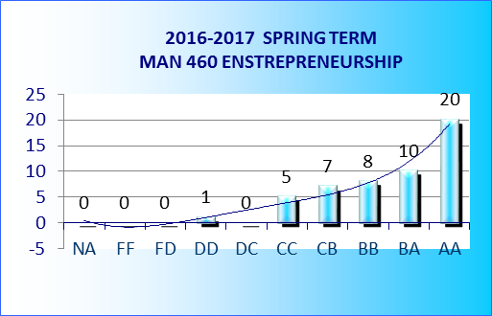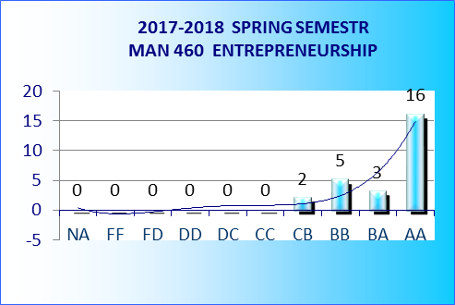

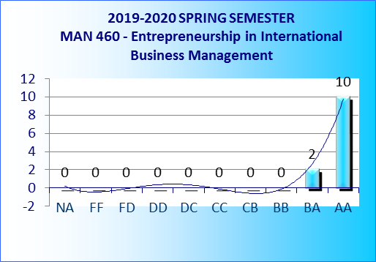
Evaluation of Business Plan
Criteria
Executive Summary |  |  |  |  |  | Briefly Sum up the each chapter in the detailed business plan |  |  |  |  |  |  |  |  |  |  |  | 10
Definiton of the business |  |  |  |  |  | It includes definitions for business and ideas that covers the following headings:  - The company's mission, vision, goals, values.  - Summarizes general strategic management  - Explains the reason for starting business  - Provide information on the products and services offered  - Business model mentioned  - The value the company offers is explained. |  |  |  |  |  |  |  |  |  |  |  | 15
Sector Analysis |  |  |  |  |  | Provides information about the sector in which the company operates, as well as information on the target market and major competitors.  This section consists of the following definitions and analyzes:  - Structure, size and overall situation of the sector  Opportunities and threats in the sector, and entry barriers, if any.  - Analysis of the main competitors: market shares, markets they serve, strategies applied and so on.  - Trends and appearance of the sector  - Target market and customer demographics (within the niche market where the company operates)  - The company's competitive advantage and its role in success...... |  |  |  |  |  |  |  |  |  |  |  | 15
Managerial Plan |  |  |  |  |  | This part includes the organizational structure of the company and explains how to manage the company. In this context, the following topics are examined:  - Ownership and why this is selected  - Organizational structure and schematics  - The role of board members' experiences, expertise and skills  - Other stakeholders (advisory board, etc.)  - Professional service firms providing management support (accounting, customer service, legal consultant, etc.) |  |  |  |  |  |  |  |  |  |  |  | 15
Marketing Plan |  |  |  |  |  | It includes information about how the proposed company will market its products and services. This information covers the following topics:  - General marketing strategy  - Marketing mix (product, price, distribution, promotion, people, peoples, power, web-social media management, etc.)  - Sales plan, sales approaches and sales management that make up sales force  - Prepare marketing planning budget |  |  |  |  |  |  |  |  |  |  |  | 15
Operation Plan |  |  |  |  |  | The plan that must be followed in order to reach the goals and objectives that the company needs in the resources and processes it needs daily for its operation. This description includes the following headings:  - Human Resources need  - Physical activity requirements  - Need for technological resources  - Lojistijk and supply chain management plan  - Application program  - Process of following processes |  |  |  |  |  |  |  |  |  |  |  | 15
Finance Plan |  |  |  |  |  | First and permanent financial calculations and financial management analysis. It includes the following topics:  - Available resources for initial funding  - Sales plan  - Income projections  - Pro-forma financial statements  - Head to head analysis  - Capital budget |  |  |  |  |  |  |  |  |  |  |  | 15

