ÇAĞ UNIVERSITY
INSTITUTE OF SOCIAL SCIENCE
Code |  |  |  | Course Title |  |  |  |  |  |  |  |  |  |  |  | Credit |  |  |  |  | ECTS
IRE 542 |  |  |  | Middle East Policy |  |  |  |  |  |  |  |  |  |  |  | (3-0)3 |  |  |  |  | 7
Prerequisites |  |  |  |  |  |  |  | None
Language of Instruction |  |  |  |  |  |  |  | English |  |  |  | Mode of Delivery |  |  |  |  |  | Face to face / Webinar
Type and Level of Course |  |  |  |  |  |  |  | Elective
Lecturers |  |  |  |  | Name(s) |  |  |  |  |  | Lecture Hours |  |  |  |  |  | Office Hours |  |  |  | Contacts
Course Coordinator |  |  |  |  | Prof.Dr.Esat ARSLAN |  |  |  |  |  |  |  |  |  |  |  | Thur. /Fri. 10.00-12.00 |  |  |  | esat@cag.edu.tr
Course Objective |  |  |  |  | The primary goal of this course is to analyze the political, economic and social characteristics of the Middle East which occupies an important place in Turkish foreign policy.
Learning Outcomes of the Course |  |  | Students who have completed the course successfully should be able |  |  |  |  |  |  |  |  |  |  |  |  |  |  |  |  | Relationship
 |  |  |  |  |  |  |  |  |  |  |  |  |  |  |  |  |  |  |  | Prog. Output |  |  | Net Effect
 |  | 1 | to describe the Middle East region and the main characteristics of this Region, |  |  |  |  |  |  |  |  |  |  |  |  |  |  |  |  | 2,6 |  |  | 4,5
 |  | 2 | to compare the Middle East countries in view of their powers, |  |  |  |  |  |  |  |  |  |  |  |  |  |  |  |  | 2,6 |  |  | 4,5
 |  | 3 | to analyze the problems of the Middle East region and their effects on Turkey,. |  |  |  |  |  |  |  |  |  |  |  |  |  |  |  |  | 9 |  |  | 3
 |  | 4 | to analyze the problems of the relations between Turkey and the Middle East countries, |  |  |  |  |  |  |  |  |  |  |  |  |  |  |  |  | 2,6 |  |  | 5,4
 |  | 5 | to explain the creation of the Turkish Middle East policy, |  |  |  |  |  |  |  |  |  |  |  |  |  |  |  |  | 2 |  |  | 5
 |  | 6 | to compare the Middle East politics of the global powers, |  |  |  |  |  |  |  |  |  |  |  |  |  |  |  |  | 9 |  |  | 3
 |  | 7 | to analyze the main characteristics of the Middle East countries and the developments of their domestic politics, |  |  |  |  |  |  |  |  |  |  |  |  |  |  |  |  | 2,6 |  |  | 4,5
 |  | 8 | to explain the developments concerning the Turkish Iraq politics |  |  |  |  |  |  |  |  |  |  |  |  |  |  |  |  | 2,6 |  |  | 4,5
 |  | 9 | to analyze the problem and cooperation fields of Turkish-Iranian relations. |  |  |  |  |  |  |  |  |  |  |  |  |  |  |  |  | 2,6 |  |  | 4,5
Course Description: The course will start with an inquiry into the definition of the Middle East region and its political, economic, and societal features. It will then move on to analyze main social, political, and military problems in the region, such as Palestinian issue and the situation in Iraq. The course will also cover in detail Turkey’s policy toward the region.
Course Contents:( Weekly Lecture Plan )
Weeks | Topics |  |  |  |  |  |  |  |  |  |  |  | Preparation |  |  |  |  |  | Teaching Methods
1 | Political, economic and social structure of the Middle East |  |  |  |  |  |  |  |  |  |  |  | Textbook |  |  |  |  |  | Presentation & Lecture  audio-visual assisted
2 | Problems in the Middle East |  |  |  |  |  |  |  |  |  |  |  | Textbook |  |  |  |  |  | Presentation, & Lecture  audio-visual assisted
3 | Palestinian question |  |  |  |  |  |  |  |  |  |  |  | Textbook |  |  |  |  |  | Presentation, & Lecture  audio-visual assisted
4 | Fundamentalism and terrorism |  |  |  |  |  |  |  |  |  |  |  | Textbook |  |  |  |  |  | Presentation & Lecture  audio-visual assisted
5 | Iraq |  |  |  |  |  |  |  |  |  |  |  | Textbook |  |  |  |  |  | Presentation & Lecture  audio-visual assisted
6 | Foreign powers and the Middle East |  |  |  |  |  |  |  |  |  |  |  | Textbook |  |  |  |  |  | Presentation & Lecture  audio-visual assisted
7 | Important countries in the Middle East |  |  |  |  |  |  |  |  |  |  |  | Textbook |  |  |  |  |  | Presentation & Lecture  audio-visual assisted
8 | Midterm Exam
9 | Midterm Exam
10 | The factors affecting Turkey’s Middle East policy |  |  |  |  |  |  |  |  |  |  |  | Textbook |  |  |  |  |  | Presentation & Lecture  audio-visual assisted
11 | Historical evolution of Turkey’s Middle East policy |  |  |  |  |  |  |  |  |  |  |  | Textbook |  |  |  |  |  | Presentation & Lecture  audio-visual assisted
12 | Turkey’s Iraqi policy |  |  |  |  |  |  |  |  |  |  |  | Textbook |  |  |  |  |  | Presentation & Lecture  audio-visual assisted
13 | Turkish-Iranian relations |  |  |  |  |  |  |  |  |  |  |  | Textbook |  |  |  |  |  | Presentation & Lecture  audio-visual assisted
14 | Turkish-Syrian relations |  |  |  |  |  |  |  |  |  |  |  | Textbook |  |  |  |  |  | Presentation & Lecture  audio-visual assisted
15 | Water issues in the Middle East |  |  |  |  |  |  |  |  |  |  |  | Textbook |  |  |  |  |  | Presentation & Lecture  audio-visual assisted
16 | An overview
REFERENCES
Textbook |  |  |  |  |  | Ahmet Davutoğlu, Stratejik Derinlik, Küre Yayınevi, İstanbul, 2014.  Tayyar Arı, Geçmişten Günümüze Ortadoğu, Dora Yayıncılık , İstanbul, 2015
Recommended Reading |  |  |  |  |  | Arthur Goldschmidt Jr., A Concise History of The Middle East, West view Press, Oxford 2010  Camron Michael Amin vd., The Modern Middle East, Oxford University Pres, Oxford 2007.  Twitter: @esatarslan06
Material Sharing |  |  |  |  |  | Presentation Slides
ASSESSMENT METHODS
Activities |  |  |  |  |  |  | Number |  |  | Effect |  |  |  | Notes
Midterm Exam |  |  |  |  |  |  | 1 |  |  | 40%
Performance |  |  |  |  |  |  |  |  |  | 10%
Effect of The Activities
Effect of The Final Exam |  |  |  |  |  |  | 1 |  |  | 50%
ECTS TABLE
Contents |  |  |  |  |  |  |  |  | Number |  |  |  |  |  | Hours |  |  |  |  |  |  | Total
Hours in Classroom |  |  |  |  |  |  |  |  | 16 |  |  |  |  |  | 3 |  |  |  |  |  |  | 48
Hours out Classroom |  |  |  |  |  |  |  |  | 16 |  |  |  |  |  | 3 |  |  |  |  |  |  | 48
Midterm Exam |  |  |  |  |  |  |  |  | 1 |  |  |  |  |  | 50 |  |  |  |  |  |  | 50
Final Exam |  |  |  |  |  |  |  |  | 1 |  |  |  |  |  | 70 |  |  |  |  |  |  | 70
Toal  Total / 30  ECTS Credit |  |  |  |  |  |  |  |  |  |  |  |  |  |  |  |  |  |  |  |  |  | 216
 |  |  |  |  |  |  |  |  |  |  |  |  |  |  |  |  |  |  |  |  |  | =216/30=7.2
 |  |  |  |  |  |  |  |  |  |  |  |  |  |  |  |  |  |  |  |  |  | 7
RECENT PERFORMANCE
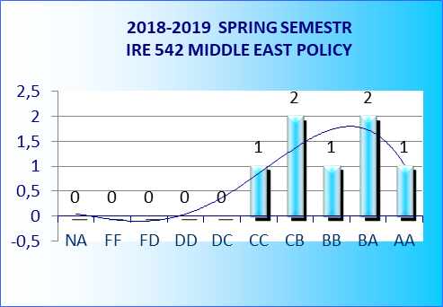 | 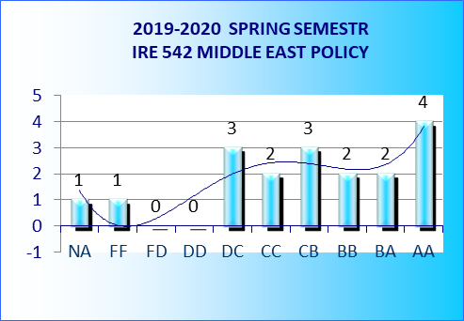
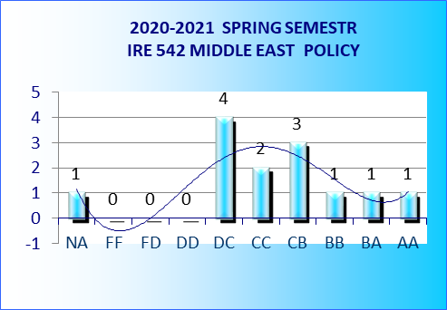

Tuesday  18.30- 21.30 | Perşembe 10.00-12.00

