ÇAĞ UNIVERSITY
INSTITUTE OF SOCIAL SCIENCES
Code |  |  |  | Course Title |  |  |  |  |  |  |  |  |  |  |  | Credit |  |  |  |  | ECTS
IRE578 |  |  |  | Turkish Foreign Policy and Current Problems |  |  |  |  |  |  |  |  |  |  |  | 3 (3-0-3) |  |  |  |  | 7
Prerequisites |  |  |  |  |  |  |  | None
Language of Instruction |  |  |  |  |  |  |  | Turkish
Type and Level of Course |  |  |  |  |  |  |  | Compulsory/ 1.Year
Lecturers |  |  |  |  | Name(s) |  |  |  |  |  | Lecture Hours |  |  |  |  |  | Office Hours |  |  |  | Contacts
Course Coordinator |  |  |  |  | Prof. Dr. Ali Engin OBA |  |  |  |  |  | TUE. 18:30-21:30 |  |  |  |  |  | Th. 9-16 |  |  |  | enginoba@hotmail.com
Others
Course Objective |  |  |  |  | One of the most important tools that nation states can use is foreign policy. It is important for the nation state to determine a foreign policy for ensuring its power and security. Within this scope, The course examines Turkish foreign policy and includes readings on foreign policy analysis.
Learning Outcomes of the Course |  |  | Students who have completed the course successfully should be able to |  |  |  |  |  |  |  |  |  |  |  |  |  |  |  |  | Relationship
 |  |  |  |  |  |  |  |  |  |  |  |  |  |  |  |  |  |  |  | Prog. Output |  |  | Net Effect
 |  | 1 | Define the Turkish Foreign Policy |  |  |  |  |  |  |  |  |  |  |  |  |  |  |  |  | 3 |  |  | 5
 |  | 2 | Identify and explain the major issues in Turkish Foreign Policy |  |  |  |  |  |  |  |  |  |  |  |  |  |  |  |  | 3 |  |  | 5
 |  | 3 | Define the process of foreign policy analysis |  |  |  |  |  |  |  |  |  |  |  |  |  |  |  |  | 3 |  |  | 5
 |  | 4 | Compare the Turkish Foreign policy with others |  |  |  |  |  |  |  |  |  |  |  |  |  |  |  |  | 3 |  |  | 5
Course Description: The course analyzes Turkish Foreign Policy towards several country.
Course Contents:( Weekly Lecture Plan )
Weeks | Topics |  |  |  |  |  |  |  |  |  |  |  | Preparation |  |  |  |  |  | Teaching Methods
1 | Introduction |  |  |  |  |  |  |  |  |  |  |  | Baskın Oran Textbook, Volume 1: period between 1919-1923 |  |  |  |  |  | Lectures
2 | Introduction to Volume 1 and the period between 1919-1923 |  |  |  |  |  |  |  |  |  |  |  | Baskın Oran Textbook, Volume 1: period between 1923-1945 |  |  |  |  |  | Presentation & Demonstration
3 | The period between 1923-1945 |  |  |  |  |  |  |  |  |  |  |  | Baskın Oran Textbook, Volume 1: period between 1945-60 |  |  |  |  |  | Presentation & Demonstration
4 | The period 1945-60 |  |  |  |  |  |  |  |  |  |  |  | Baskın Oran Textbook, Volume 1: period between 1960-80 |  |  |  |  |  | Presentation & Discussion
5 | The period 1960-1980 |  |  |  |  |  |  |  |  |  |  |  | Baskın Oran Textbook, Volume 2, period between 1980-90 |  |  |  |  |  | Presentation & Discussion
6 | 2. Volume: between 1980-1990 |  |  |  |  |  |  |  |  |  |  |  | Baskın Oran Textbook, Volume 2, period between 1990-2001 |  |  |  |  |  | Presentation & Discussion
7 | The Period 1990-2001 |  |  |  |  |  |  |  |  |  |  |  |  |  |  |  |  |  | Presentation & Demonstration
8 | Midterm exam
9 | 3. Volume 2001-2012 Period |  |  |  |  |  |  |  |  |  |  |  | Baskın Oran Textbook, Volume 3 |  |  |  |  |  | Presentation & Demonstration
10 | 2001-2012 Period |  |  |  |  |  |  |  |  |  |  |  | Baskın Oran Textbook, Volume 3 |  |  |  |  |  | Presentation & Discussion
11 | Conceptual Framework, Theoretical Approaches, rationality |  |  |  |  |  |  |  |  |  |  |  | Ertan Efegil Chapter 1. 2. 3. 4. |  |  |  |  |  | Presentation & Discussion
12 | System Approaches, Decision Making Approaches, Bureaucratic Political Approaches,  Official Institutions Affecting Foreign Policy |  |  |  |  |  |  |  |  |  |  |  | Ertan Efegil Chapter 5. 6. 7. 8. |  |  |  |  |  | Presentation & Discussion
13 | Non-State Actors influencing Foreign Policy, International Factors Affecting Foreign Policy,What is Successful Foreign Policy? |  |  |  |  |  |  |  |  |  |  |  | Ertan Efegil Chapter 9. 10. 11. and Conclusion |  |  |  |  |  | Presentation & Discussion
14 | Article Review |  |  |  |  |  |  |  |  |  |  |  |  |  |  |  |  |  | Presentation & Discussion
15 | Article Review |  |  |  |  |  |  |  |  |  |  |  |  |  |  |  |  |  | Presentation & Discussion
16 | final
REFERENCES
Textbook |  |  |  |  |  | Baskın Oran 1. 2. Ve 3. Cilt Türk Dış Politikası Kitapları, İletişim Yayınları  Bezen Balamir Coşkun ve İnan Rüma (Der.).(2022). Dış Politika Analizi Konu, Kuram, Yöntem, İstanbul Bilgi Üniversitesi Yayınları  Ertan Efegil, 2016, Dış Politika Analizi, Nobel Yayıncılık  Ali Balcı, Türkiye Dış Politikası, 2013, Nesil Yayın Grubu.
ASSESSMENT METHODS
Activities |  |  |  |  |  |  | Number |  |  | Effect |  |  |  | Notes
Midterm Exam |  |  |  |  |  |  | 1 |  |  | 30%
Presentation |  |  |  |  |  |  | 2 |  |  | 20%
Effect of The Activities |  |  |  |  |  |  |  |  |  | 50%
Effect of The Final Exam |  |  |  |  |  |  | 1 |  |  | 50%
ECTS TABLE
Contents |  |  |  |  |  |  |  |  | Number |  |  |  |  |  | Hours |  |  |  |  |  |  | Total
Hours in Classroom |  |  |  |  |  |  |  |  | 16 |  |  |  |  |  | 3 |  |  |  |  |  |  | 48
Hours out Classroom |  |  |  |  |  |  |  |  | 16 |  |  |  |  |  | 3 |  |  |  |  |  |  | 48
Presentation |  |  |  |  |  |  |  |  | 3 |  |  |  |  |  | 18 |  |  |  |  |  |  | 54
Midterm Exam |  |  |  |  |  |  |  |  | 1 |  |  |  |  |  | 27 |  |  |  |  |  |  | 30
Final Exam |  |  |  |  |  |  |  |  | 1 |  |  |  |  |  | 30 |  |  |  |  |  |  | 30
Total  Total / 30  ECTS Credit |  |  |  |  |  |  |  |  |  |  |  |  |  |  |  |  |  |  |  |  |  | 210
 |  |  |  |  |  |  |  |  |  |  |  |  |  |  |  |  |  |  |  |  |  | =210/30=7
 |  |  |  |  |  |  |  |  |  |  |  |  |  |  |  |  |  |  |  |  |  | 7
RECENT PERFORMANCE
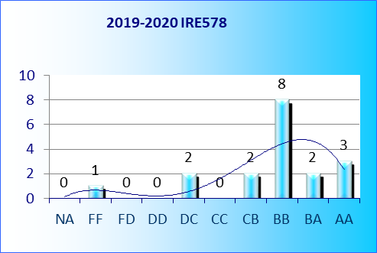 | 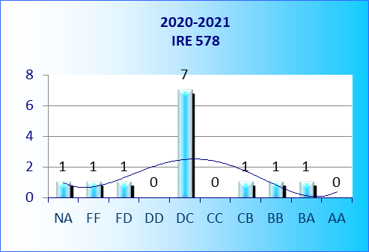
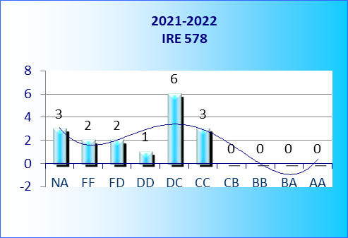 | 